Name: ____________________________________ Period: _______ Date: ____________________
SPRING BENCHMARK 1 BIOLOGY STUDY GUIDE
Semester 1 Topic
Energy : ATP
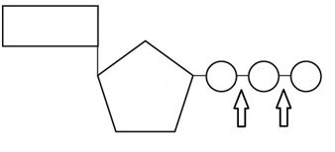
The molecule to the left is an ATP molecule.
Label and list all three parts:

This is a source of ___________ energy.
How do you get the energy out of this molecule?
Color the arrow which represents the most energy yellow.
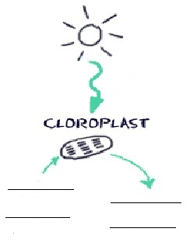
Circle what you would remove to create ADP.
Energy: Photosynthesis
Write out the equation for photosynthesis. Remember reactants are going in and products coming out.

The ultimate source of energy is the ________________.
Which type of organisms due photosynthesis? Autotrophs or Heterotrophs
How do the following variables impact the rate of photosynthesis?
Light Intensity: Increase/Decrease/Stay the Same
Temperature: Increase/Decrease/Stay the Same
Amount of Carbon dioxide Present: Increase/Decrease/Stay the Same
Energy: Cellular Respiration
When you compare the equation for photosynthesis and cellular respiration what do you notice about the process?

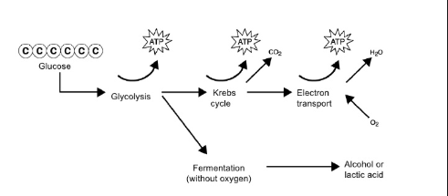
What are the three parts of aerobic respiration?
a)
b)
c)
How is fermentation different from aerobic respiration?
_________________________
What is another name for fermentation?
What are the two type of fermentation? ____________________ and _______________
Label the amount of ATP above. How many total ATP for aerobic respiration?_____ anaerobic respiration? ______
Where in the cell does Cellular Respiration occur?
Semester 2 Topics
History
Match each scientist with their contribution to the structure of DNA
_______1. Watson and Crick a. Transformation

_______2. Chargaff b. A = T and C = G

_______3. Franklin c. Identified structure of DNA

_______4. Griffin d. Identified DNA as the inherited material instead of protein.

_______5. Hershey and Chase e. Her photographs were used to help identify the overall structure of DNA

DNA and RNA
- Structure:
- Where is DNA located in the cell? _______________________
- What does the circled section represent? ___________________
- DNA strands run in opposite directions, due to this they are said to be __________________________.
- What holds the 2 strands together? _____________
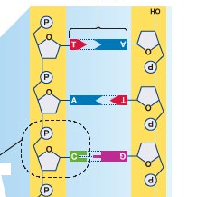
d. What is the monomer of DNA and what are the three parts to the
monomer?
Monomer: ______________________________

Parts of Monomer: _______________________________
_______________________________
_______________________________

- Name three differences between DNA and RNA. _________________________________________ _________________________________________
_________________________________________
e. Label the different types of RNA and their parts below.

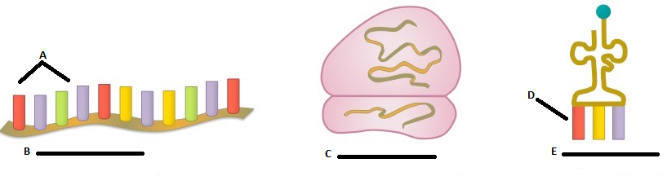

- DNA Replication:
  - After DNA replication, the two new strands of DNA are composed of one ___________ strand and one _____________ strand.

This kind of replication is called ______________________________________.

  - What enzyme unwinds and unzips the original DNA strand? ___________________________________

  - What enzyme brings in the new DNA nucleotides? __________________________________________
  - Given a segment of DNA, what complimentary nucleotides would match up during DNA replication?

A T G C T T T A C G C G A

_________________________________
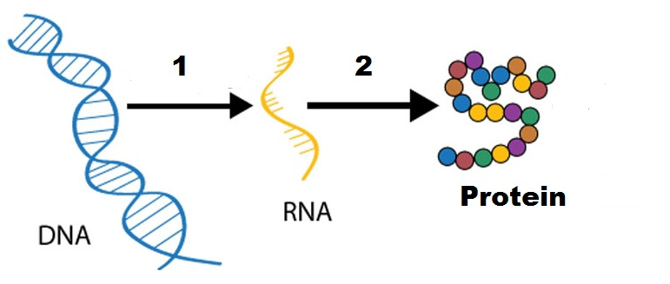
- Protein Synthesis: - Refer to the diagram provided to help you answer the questions that follow

  - What are the two parts of protein synthesis?
1) ________________________
2) ________________________
  - Where does transcription occur in the cell? ____________________
  - What is the purpose of transcription? Use a strand of _____________ to produce ___________
  - Where does translation occur in the cell? _____________________
  - What is the purpose of translation? Use the strand of ____________ to make a ________________
  - How are a codon and anti-codon different? _________________________________________________
  - What is another name for a protein? ________________________ chain
  - What is the monomer for a protein? ________________________________
  - What type of bond holds these monomers together? _________________________________________
  - Label the image below and explain what is going on.
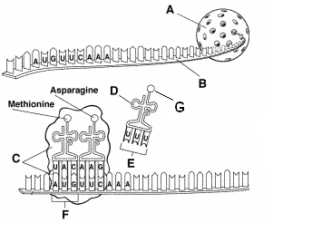
A: B: C: D: E: F: G:

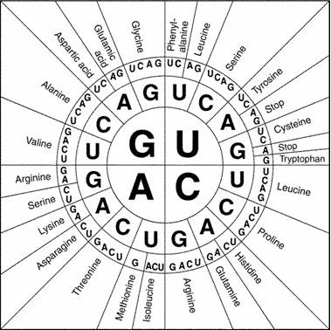
  - For the following piece of DNA below, first transcribe it into mRNA, then translate it into a protein. Use the codon chart.
DNA segment: CGA TTA CGG CTT AAG CTA
mRNA segment:

Polypeptide chain:

Mutations and Biotechnology
- What is a mutation? __________________________________________________________________________
- Mutations are commonly identified as negative events, however mutations are the original and ultimate source of ________________________.
- There are two categories of mutations: 1. Chromosomal 2. ____________________
- How do mutations in somatic cells impact an organism differently from a mutation in a gamete?

__________________________________________________________________________________________

- What are the four types of chromosomal mutations? Label them in the spaces below.

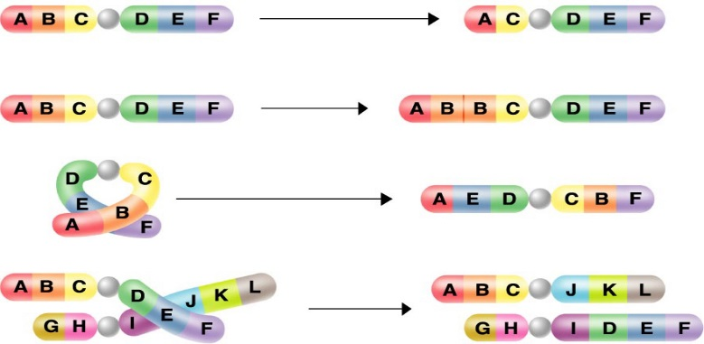

- How is polyploidy different from other chromosomal mutations? _____________________________________

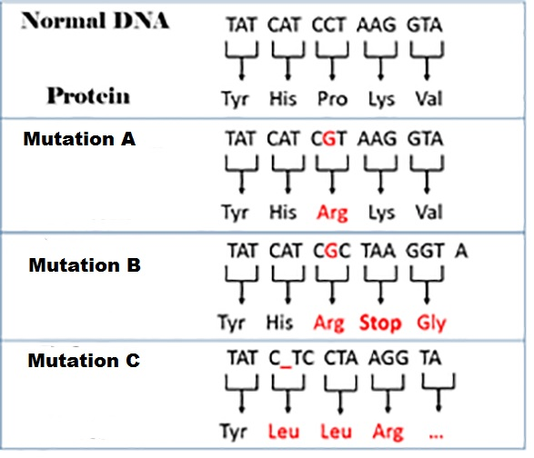
__________________________________________________________________________________________

- Of the types of gene mutations, how is a substitution mutation different from an insertion or deletion mutation?

______________________________________________
______________________________________________
______________________________________________
______________________________________________
Identify each in the image to the right:

- What is a silent mutation and how can you tell if a mutation is silent? ______________________________________________
______________________________________________
___________________________________________________________________________________________

- What is genetic engineering?

- Match the following terms below:
______ Cloning a. a technique used to separate DNA fragments based on their size
______ Selective Breeding b. a process which replaces non-functioning genes with genes that function
______ Gene Therapy c. to make a genetically identical copy using a somatic cell’s DNA
______ Gel Electrophoresis d. method of breeding that allows only individuals with desired traits to reproduce
______ Genetically Modified e. segment of DNA that codes for a particular trait
______ Gene f. Organisms, commonly food, who’s DNA has been altered to contain the
desired trait.

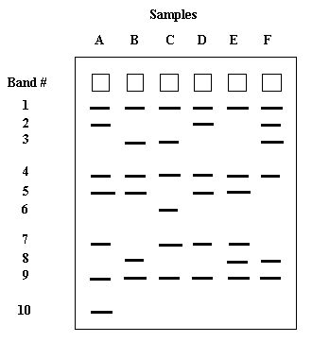
- Read the following gel:

Sample A is the mother
Sample B is the child.
Who is the father?

