Benchmark #1 Top Ten Review Name: _______________________________________

Topic/Question | Answer
Scientific Method

Independent/Dependent Variables

Characteristics of Living Things
Homeostasis
Stimuli

What is not a
characteristic?

Viruses  Parts  Reproduction  Provirus (Prophage)  Dormant  DNA vs. RNA Virus  Vaccinations | 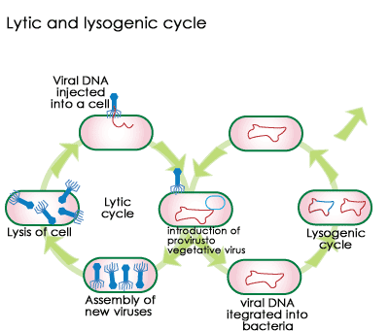
Parts of a Prokaryote

Bacteria

Basics –
Reproduction/Energy

Bacterial Shapes

Uses

Endospore

Archaebacteria v.
Eubacteria
Cell Wall

Locations

Examples?

Protists  Fungus Like  Animal Like  Plant Like  Special Structures – Cilia, Flagella, Contractile Vacuole, Pseudopods | 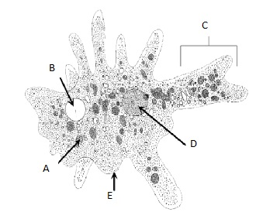  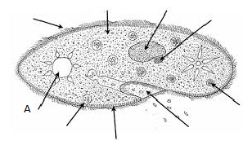
Fungi
Basics – Energy
Hyphae
Mycelium

4 Phylums
Common Name
Examples

Plants  Characteristics of Each  Division  Tropisms | 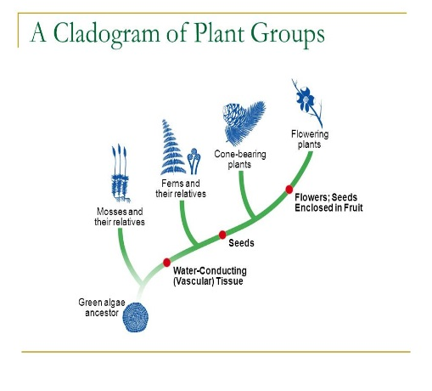
Flower Parts and Functions | 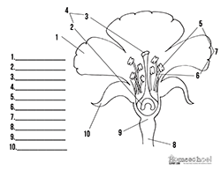
Animal
Basics
Radial, Bilateral, or
Asymmetrical

Segmented Body Plan

Endothermic

Invertebrates (8)

Phylum Chordata
Vertebrates (7)

Classification Basics  Taxonomic Levels  Bionomial  Nomenclature  Dichotomous Key | 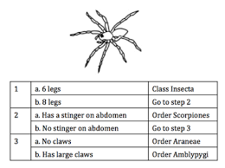
Scientific Tools  Cladograms | 