Bacteria Review Guide
Vocabulary Matching:
_____ 1. Archaebacteria a. Long, whip-like tail used for movement by some bacteria
_____ 2. Eubacteria b. Round, spherical shape of bacteria
_____ 3. Bacillus c. Arrangement of bacteria in clusters like grapes
_____ 4. Coccus d. Form of sexual reproduction in bacteria producing genetically different cells
_____ 5. Spirillum e. Bacteria that causes a disease
_____ 6. Strepto- f. Bacteria that do not need to use or cannot have oxygen
_____ 7. Staphylo- g. Dormant, tough, protective shell produced by some bacteria when conditions are unfavorable
_____ 8. Flagella h. Rod shape of bacteria
_____ 9. Binary Fission i. A weakened or dead form of pathogen injected into an organism to elicit an immune response
_____ 10. Conjugation j. A chemical drug that kills bacteria
_____ 11. Aerobic k. Corkscrew or spiral shape of bacteria
_____ 12. Anaerobic l. Bacteria that do not have peptidoglycan in their cell walls; halophiles and methanogens
_____ 13. Endospore m. Bacteria that need or use oxygen
_____ 14. Vaccine n. Form of asexual reproduction in bacteria producing genetically identical cells
_____ 15. Antibiotic o. Bacteria that do have peptidoglycan in their cell walls; Streptococcus aureus
_____ 16. Pathogen p. Arrangement of bacteria in chains
17. Label the following parts of a bacterium below using the following word bank: cell wall, cell membrane, DNA, flagella, ribosomes, cytoplasm.
18. Draw the following shapes and arrangements of bacteria:
a. Streptococcus

b. Staphylococcus

c. Streptobacillus
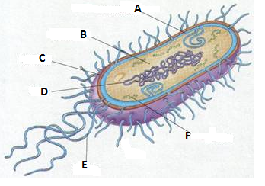
19. Name 3 beneficial uses of bacteria: _________________________________________________________________
20. List the two main differences between prokaryotes and eukaryotes:
a.
b.

