Bacteria Review Guide Key

Vocabulary Matching:

__L__ 1. Archaebacteria a. Long, whip-like tail used for movement by some bacteria

__O__ 2. Eubacteria b. Round, spherical shape of bacteria

__H__ 3. Bacillus c. Arrangement of bacteria in clusters like grapes

__B__ 4. Coccus d. Form of sexual reproduction in bacteria producing genetically different cells

__K__ 5. Spirillum e. Bacteria that causes a disease

__P__ 6. Strepto- f. Bacteria that do not need to use or cannot have oxygen

__C__ 7. Staphylo- g. Dormant, tough, protective shell produced by some bacteria when conditions are unfavorable

__A__ 8. Flagella h. Rod shape of bacteria

__N__ 9. Binary Fission i. A weakened or dead form of pathogen injected into an organism to elicit an immune response

__D__ 10. Conjugation j. A chemical drug that kills bacteria

__M__ 11. Aerobic k. Corkscrew or spiral shape of bacteria

__F__ 12. Anaerobic l. Bacteria that do not have peptidoglycan in their cell walls; halophiles and methanogens

__G__ 13. Endospore m. Bacteria that need or use oxygen

__I___ 14. Vaccine n. Form of asexual reproduction in bacteria producing genetically identical cells

__J__ 15. Antibiotic o. Bacteria that do have peptidoglycan in their cell walls; *Streptococcus aureus*

__E__ 16. Pathogen p. Arrangement of bacteria in chains

17. Label the following parts of a bacterium below using the following word bank: cell wall, cell membrane, DNA, flagella, ribosomes, cytoplasm.

18. Draw the following shapes and arrangements of bacteria:

a. *Streptococcus*



b. *Staphylococcus*

c. *Streptobacillus*

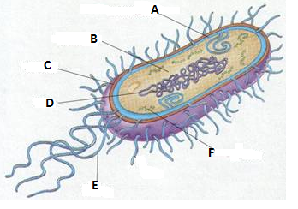

Ribosomes

Flagella

DNA

Cell wall

Cytoplasm

Cell membrane

19. Name 3 beneficial uses of bacteria: _some make medicines, food production, recycling, cleaning up oil spills__

20. List the two main differences between prokaryotes and eukaryotes:

a. Prokaryotes do not have a membrane bound nucleus and eukaryotes do have a membrane bound nucleus.

b. Prokaryotes do not have membrane bound organelles and eukaryotes do have membrane bound organelles.