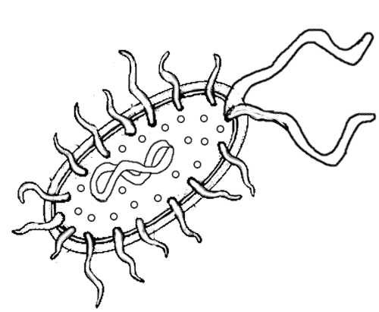
Bacteria: 2 Kingdoms

Domain Archae
Domain Bacteria
Prokaryote

Bacterial Shape Arrangements
Coccus | Bacillus | Spirillium
Movement
Reproduction
Energy
Protection

Good? Bad? Treatment?

