Name: __Key______________________________________ Period: _______ Date: _______________________
DNA, PROTEIN SYNTHESIS, AND MUTATIONS STUDY GUIDE
Part A: DNA and RNA Review
1. What are the 3 main differences between DNA and RNA?
 | DNA | RNA
Number of Strands | 2 | 1
Nitrogen Bases | Adenine, Thymine, Guanine, Cytosine | Adenine, Uracil, Guanine, Cytosine
Sugar Present in nucleotide | Deoxyribose | Ribose

2. For the characteristics below, mark (A) for DNA only, (B) for RNA only, or (C) for both DNA and RNA.
__A__ 1. Deoxyribose sugar __C__ 10. Genetic Information
__C__ 2. Phosphate groups __C__ 11. Is a nucleic acid
__B__ 3. 3 types __A__ 12. Double stranded
__C__ 4. Nitrogen bases (G, A, and C) __B__ 13. Single stranded
__C__ 5. Nucleotide is the monomer __A__ 14. Function is contains instructions for making proteins
__A__ 6. Double helix __B__ 15. Function is to copy the instructions and make proteins
__B__ 7. Single helix __A__ 16. Located in the nucleus only
__B__ 8. Nitrogen base (U) __B__ 17. Located in nucleus, cytoplasm or ribosomes
__A__ 9. Nitrogen base (T) __B__ 18. Ribose sugar

Part B: DNA Replication Review
1. Why does a cell go through the process of DNA replication? To make a copy of the DNA before the cell goes through mitosis
2. Where in the cell does DNA replication take place? Nucleus
3. What part of the cell cycle does DNA replicate? S phase of interphase
4. What enzyme unwinds and unzips DNA to begin replication? Helicase
5. What enzyme brings in the new nucleotides on both sides of the DNA? DNA polymerase
6. DNA replication is described as being semi-conservative. This means that both of the copies of DNA are composed of ½ original strand and ½ new strand.
7. Using the ½ strand of DNA below, create the other ½ strand by matching the complementary bases. These are considered the parent strands. Highlight them in yellow. Now separate the parent strands and write in the new strands on both sides. Highlight the new strands in pink. These are called the daughter strands.
Parent: A T G C C C A T T T T A C C G Parent: A T G C C C A T T T T A C C G
Parent: T A C G G G T A A A A T G G C Daughter: T A C G G G T A A A A T G G C
Daughter: A T G C C C A T T T T A C C G
Parent: T A C G G G T A A A A T G G C
Part C. RNA
1. What are the 3 types of RNA? Label them on the pictures below.
a. Which type of RNA goes into the nucleus and retrieves the genetic information from DNA? mRNA
b. Which type of RNA makes up ribosomes? rRNA
c. Which type of RNA brings amino acids in to the ribosome while the message is read? tRNA
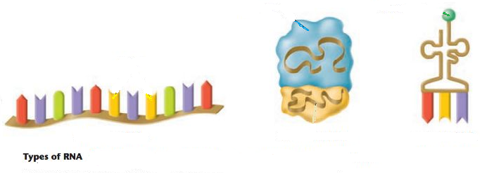
tRNA
rRNA
mRNA

2. Where in the cell is RNA found? Nucleus, ribosomes, cytoplasm
3. What are the 3 parts to an RNA nucleotide? Ribose sugar, phosphate group, nitrogen base (A, U, C, or G)
4. Can DNA leave the nucleus? yes
5. Why, then, do cells need RNA? To make proteins which carry out the directions initially coded in the DNA
6. What does making a protein have to do with your genetic traits coded by your DNA? It is a protein that expresses the trait coded by the DNA or carries out the directions of the DNA.
7. What is the monomer unit for a protein? Amino acid
8. What bases pair together when RNA matches up with DNA? A with U and C with G

Part D: Protein Synthesis
1. What are the two stages in protein synthesis? Transcription and Translation.
2. What happens in transcription? DNA mRNA
3. Where in the cell does transcription take place? Nucleus
4. What enzyme aids in the production of mRNA by bringing in the RNA nucleotides? RNA polymerase
5. What type of RNA is made during transcription? mRNA
6. mRNA is divided into sets of 3 nitrogen bases called codons.
7. Put the following steps in order (1-4) for transcription:
__4__ mRNA leaves the nucleus with the DNA message and heads to the ribosome.
__2__ RNA nucleotides enter the nucleus and RNA polymerase attaches the complementary nucleotides to the DNA.
__1__ DNA unwinds and unzips inside the nucleus.
__3__ A single strand of mRNA is created and then edited, removing introns and putting exons together.
8. Once the RNA segment is created and detaches where does it go? Leaves the nucleus, travels through the cytoplasm to a ribosome.
9. Using the following segment of DNA create an mRNA strand:
DNA segment: CGA TTA CGG CTT AAG CTA
mRNA segment: GCU AAU GCC GAA UUC GAU
10. Where does translation occur? Ribosome
11. What is the end goal of translation? To make a polypeptide chain (protein).
12. What is the codon that starts the process of translation? What is the name of its corresponding amino acid?
AUG methionine
13. What are the three stop codons that terminate translation? UGA UAA UAG
14. What type of RNA brings the amino acids to the growing polypeptide chain? tRNA
15. What are the 3 bases on this molecule called? anticodon
16. Put the following steps in order (1-5) for translation:
__2__ mRNA is pulled through the ribosome and the message is read one codon at a time.
__3__ tRNA comes into the ribosome (carrying an amino acid) and its anticodon matches up to the codon on mRNA.
__1__ mRNA attaches to the ribosome.
__4__ Amino acids are linked together, beginning with the start codon and ending with one of the stop codons.
__5__ A polypeptide chain (protein) is made and leaves the ribosome to go golgi bodies to be folded/packaged.
17. Using the mRNA strand created above, divide it into codons, and tell what tRNA anticodons would be used to bring amino acids to this molecule. Then, use the codon chart on the next page to translate the message into the correct order of amino acids.
mRNA segment from above: GCU AAU GCC GAA UUC GAU
tRNA anticodons: CGA UUA CGG CUU AAG CUA
Amino acids: Alanine-Asparagine-Alanine-Gutamic Acid-Phenylalanine-Aspartic Acid
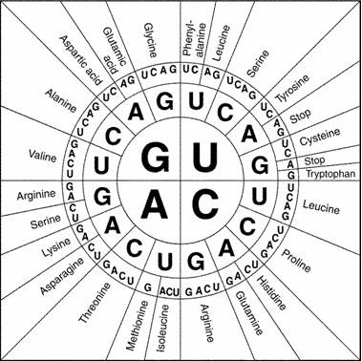

Part E: Mutations
1. Fill in the following concept map using the following terms: Gene, Translocation, Point, Deletion, Duplication, Chromosome, Frameshift, Inversion, change, substitution, silent, insertion, deletion.
Mutations—A change in the DNA

Chromosome Abnormalities/Mutations- affects large portions of DNA
Gene Mutations- a change in a small DNA sequence

Point Mutations- DNA is incorrect on only one location due to the substitution of a base. If the substitution does not code for a different amino acid, these are sometimes called silent mutations.
Frameshift Mutations- the addition or deletion of a single base changes the reading of all DNA triplets.
Deletion- a portion of a chromosome is missing
Inversion- a portion of the chromosome is turned around

Translocation- a portion of a chromosome has incorrectly attached to another chromosome

Duplication- there is too much of a portion of a chromosome
Insertion when a base is added
Deletion when a base is removed

2. Gene Mutation Examples:
Original DNA Sequence: T A C A C C T T G G C G A C G A C T
mRNA Sequence: A U G U G G A A C C G C U G C U G A
Amino Acid Sequence: Met – Tryp- Asp - Arg - Cys - Stop

Mutated DNA Sequence #1: T A C G A C C T T G G C G A C G A C T
What’s the mRNA sequence? (Circle the change) A U G C U G G A A C C G C U G C U G A
What will be the amino acid sequence? Met – Leu – Glut. Acid – Pro – Leu – Leu - A
Will there likely be effects? yes
What kind of mutation is this (insertion, deletion or substitution)? Was it frameshift mutation, silent, or neither?

Mutated DNA Sequence #2: T A C A C C T T A G C G A C G A C T
What’s the mRNA sequence? (Circle the change) A U G U G G A A U C G C U G C U G A
What will be the amino acid sequence? Met – Tryp- Asp - Arg - Cys - Stop
Will there likely be effects? No
What kind of mutation is this (insertion, deletion or substitution)? Was it frameshift mutation, silent, or neither?

Mutated DNA Sequence #3: T A C A C C T T G G G A C G A C T
What will be the corresponding mRNA sequence? A U G U G G A A C C C U G C U G A
What will be the amino acid sequence? Met – Tryp – Asp – Pro – Ala - GA
Will there likely be effects? Yes
What kind of mutation is this (insertion, deletion or substitution)? Was it frameshift mutation, silent, or neither?

3. Chromosome Mutation Examples: What types of chromosome mutations are shown below?
Deletion
Duplication

Inversion
Translocation
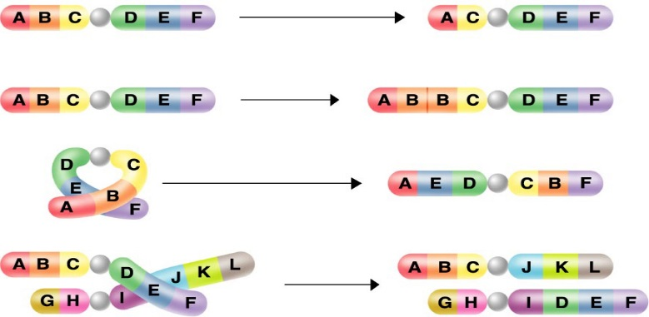
4. A picture of chromosomes taken from an organism’s cells is called a karyotype.
5. When multiple copies of chromosomes are present in plants, resulting in large fruits, it is called polyploidy.
6. When only one chromosome of a pair is present in a person’s cells, it is called a monosomy of that pair.
7. When three copies of a chromosome are present in a person’s cells, it is called a trisomy of that pair.
8. A person should have 46 chromosomes, or 23 pairs.
9. The sex chromosomes are X and Y.
10. The other chromosomes (pairs 1 – 22) are called autosomes.
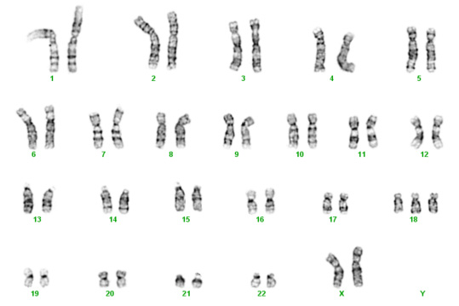
11. Look at the karyotype to the right and answer the questions below.
12. Is this individual a male or a female? female
13. Is there an abnormality in this individual? If so where? Yes, # 18
14. What is this kind of abnormality called? Trisomy 18
15. Is this mutation affecting a small or a large portion of DNA? Large
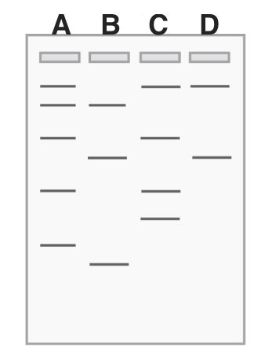
Part F: Genetic Technology – Gel Electrophoresis
1. What are some applications for gel electrophoresis?
Paternity Testing, Determine relationships between and within a
Species, identification of a crime suspect.

2. What causes the segments of DNA to move from one end to the other of the gel? An applied current, which will force the negatively charged DNA to move to the positive end of the gel.

3. Which segments will move the furthest? Shortest segments

4. Which lane has the shortest segment of DNA? B

5. If these letters A-D represent different species, which
one might be most closely related to A? C, because they share so
many bands in common.

6. If A is the mother’s DNA and B is the father’s DNA, which
one is the only one that could be his kid? D

Part G: Pedigree
1. a. How many generations are there in the pedigree? ____4_____
b. How many marriages are there? ___3____
c. How many children did the first couple (couple in row I) have? ____2______
d. How many children did the third couple (couple in row III) have? ______7_______

2. a. How many males are there? _____8_______
b. How many males have hemophilia? ____3_____
c. How many female are there? ____8____
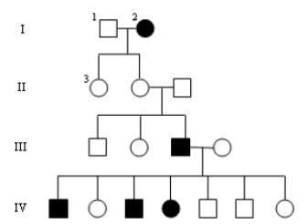
d. How many females have hemophilia? __2___
e. What is the genotype of the male and female in
generation 1?
______X^{h}Y male and X^{h}X^{h} female_______

