Name: ____________________________________________ Period: _______ Date: _______________________
DNA, PROTEIN SYNTHESIS, AND MUTATIONS STUDY GUIDE
Part A: DNA and RNA Review
1. What are the 3 main differences between DNA and RNA?
 | DNA | RNA
Number of Strands
Nitrogen Bases
Sugar Present in nucleotide

2. For the characteristics below, mark (A) for DNA only, (B) for RNA only, or (C) for both DNA and RNA.
______ 1. Deoxyribose sugar ______ 10. Genetic Information
______ 2. Phosphate groups ______ 11. Is a nucleic acid
______ 3. 3 types ______ 12. Double stranded
______ 4. Nitrogen bases (G, A, and C) ______ 13. Single stranded
______ 5. Nucleotide is the monomer ______ 14. Function is contains instructions for making proteins
______ 6. Double helix ______ 15. Function is to copy the instructions and make proteins
______ 7. Single helix ______ 16. Located in the nucleus only
______ 8. Nitrogen base (U) ______ 17. Located in nucleus, cytoplasm or ribosomes
______ 9. Nitrogen base (T) ______ 18. Ribose sugar

Part B: DNA Replication Review
1. Why does a cell go through the process of DNA replication? _____________________________________________
2. Where in the cell does DNA replication take place? __________________________
3. What part of the cell cycle does DNA replicate? _____________________________
4. What enzyme unwinds and unzips DNA to begin replication? ______________________
5. What enzyme brings in the new nucleotides on both sides of the DNA? __________________________
6. DNA replication is described as being semi-conservative. This means that both of the copies of DNA are composed of ½ ____________________ strand and ½ ___________________ strand.
7. Using the ½ strand of DNA below, create the other ½ strand by matching the complementary bases. These are considered the parent strands. Highlight them in yellow. Now separate the parent strands and write in the new strands on both sides. Highlight the new strands in pink. These are called the daughter strands.
Parent: A T G C C C A T T T T A C C G Parent: A T G C C C A T T T T A C C G
Parent: Daughter:
Daughter:
Parent:
Part C. RNA
1. What are the 3 types of RNA? Label them on the pictures below.
36. Which type of RNA goes into the nucleus and retrieves the genetic information from DNA? _______________
37. Which type of RNA makes up ribosomes? _________________
38. Which type of RNA brings amino acids in to the ribosome while the message is read? _________________
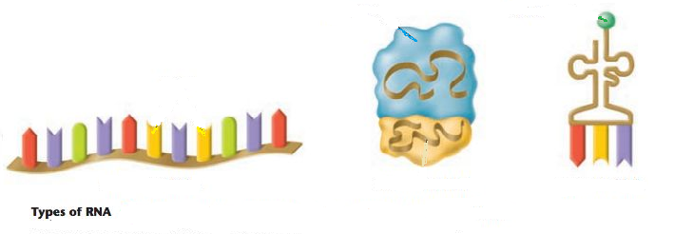

2. Where in the cell is RNA found? ___________________________________________________________
3. What are the 3 parts to an RNA nucleotide? ______________________________________________________________
4. Can DNA leave the nucleus? __________________________
5. Why, then, do cells need RNA? _________________________________________________________________________
6. What does making a protein have to do with your genetic traits coded by your DNA? ______________________________
________________________________________________________________________________________________________
7. What is the monomer unit for a protein? _________________________________________
8. What bases pair together when RNA matches up with DNA? ___________________________________________________

Part D: Protein Synthesis
1. What are the two stages in protein synthesis? __________________________ and __________________________
2. What happens in transcription? DNA ______________
3. Where in the cell does transcription take place? ______________________
4. What enzyme aids in the production of mRNA by bringing in the RNA nucleotides? _____________________________
5. What type of RNA is made during transcription? ___________________
6. mRNA is divided into sets of 3 nitrogen bases called ___________________.
7. Put the following steps in order (1-4) for transcription:
______ mRNA leaves the nucleus with the DNA message and heads to the ribosome.
______ RNA nucleotides enter the nucleus and RNA polymerase attaches the complementary nucleotides to the DNA.
______ DNA unwinds and unzips inside the nucleus.
______ A single strand of mRNA is created and then edited, removing introns and putting exons together.
8. Once the mRNA segment is created and detaches where does it go? _________________________
9. Using the following segment of DNA create an mRNA strand:
DNA segment: CGA TTA CGG CTT AAG CTA
mRNA segment:
10. Where does translation occur? _________________________
11. What is the end goal of translation? To make a _______________________.
12. What is the codon that starts the process of translation? What is the name of its corresponding amino acid?
__________________________ _____________________________
13. What are the three stop codons that terminate translation? ___________ ____________ ___________
14. What type of RNA brings the amino acids to the growing polypeptide chain? _______________
15. What are the 3 bases on this molecule called? ____________________
16. Put the following steps of translation in order:
______ mRNA is pulled through the ribosome and the message is read one codon at a time.
______ tRNA comes into the ribosome (carrying an amino acid) and its anticodon matches up to the codon on mRNA.
______ mRNA attaches to the ribosome.
______ Amino acids are linked together, beginning with the start codon and ending with one of the stop codons.
______ A polypeptide chain (protein) is made and leaves the ribosome to go golgi bodies to be folded/packaged.
17. Using the mRNA strand created above, divide it into codons, and tell what tRNA anticodons would be used to bring amino acids to this molecule. Then, use the codon chart on the next page to translate the message into the correct order of amino acids.
mRNA segment from above: GCU AAU GCC GAA UUC GAU
tRNA anticodons: ________________________________________________________
Amino acids: _______-_________-________-________-________-________
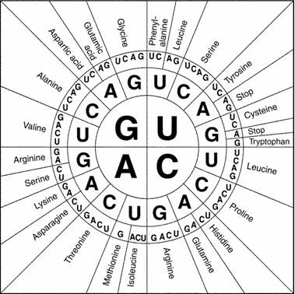

Part E: Mutations
1. Fill in the following concept map using the following terms: Gene, Translocation, Point, Deletion, Duplication, Chromosome, Frameshift, Inversion, change, substitution, silent, insertion, deletion.
Mutations—A _____________ in the DNA

____________________ Abnormalities/Mutations- affects large portions of DNA
____________ Mutations- a change in a small DNA sequence

__________ Mutations- DNA is incorrect on only one location due to the __________ of a base. If the substitution does not code for a different amino acid, these are sometimes called ________ mutations.
__________ Mutations- the addition or deletion of a single base changes the reading of all DNA triplets.
___________- a portion of a chromosome is missing
___________- a portion of the chromosome is turned around

_____________- a portion of a chromosome has incorrectly attached to another chromosome

____________- there is too much of a portion of a chromosome
_________ when a base is removed
________ when a base is added

2. Gene Mutation Examples:
Original DNA Sequence: T A C A C C T T G G C G A C G A C T
mRNA Sequence:
Amino Acid Sequence:

Mutated DNA Sequence #1: T A C G A C C T T G G C G A C G A C T
What’s the mRNA sequence? (Circle the change)
What will be the amino acid sequence?
Will there likely be effects?
What kind of mutation is this (insertion, deletion or substitution)? Was it frameshift mutation, silent, or neither?

Mutated DNA Sequence #2: T A C A C C T T A G C G A C G A C T
What’s the mRNA sequence? (Circle the change)
What will be the amino acid sequence?
Will there likely be effects?
What kind of mutation is this (insertion, deletion or substitution)? Was it frameshift mutation, silent, or neither?

Mutated DNA Sequence #3: T A C A C C T T G G G A C G A C T
What will be the corresponding mRNA sequence?
What will be the amino acid sequence?
Will there likely be effects?
What kind of mutation is this (insertion, deletion or substitution)? Was it frameshift mutation, silent, or neither?

3. Chromosome Mutation Examples: What types of chromosome mutations are shown below?
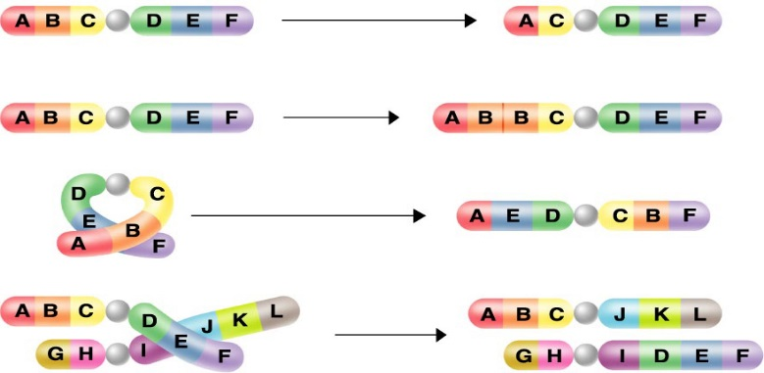
4. A picture of chromosomes taken from an organism’s cells is called a __________________________.
5. When multiple copies of chromosomes are present in plants, resulting in large fruits, it is called ______________________.
6. When only one chromosome of a pair is present in a person’s cells, it is called a ___________________ of that pair.
7. When three copies of a chromosome are present in a person’s cells, it is called a ___________________ of that pair.
8. A person should have _______ chromosomes, or _______ pairs.
9. The sex chromosomes are _______ and _______.
10. The other chromosomes (pairs 1 – 22) are called ____________________.
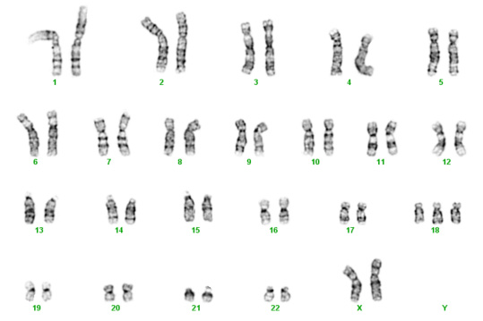
11. Look at the karyotype to the right and answer the questions below.
12. Is this individual a male or a female? _______________
13. Is there an abnormality in this individual? If so where? _________
14. What is this kind of abnormality called? ______________________
15. Is this mutation affecting a small or a large portion of DNA? ______
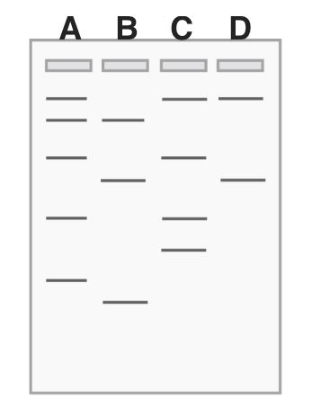
Part F: Genetic Technology – Gel Electrophoresis
1. What are some applications for gel electrophoresis?

2. What causes the segments of DNA to move from one end to the other of the gel?

3. Which segments will move the furthest?

4. Which lane has the shortest segment of DNA?

5. If these letters A-D represent different species, which
one might be most closely related to A?

6. If A is the mother’s DNA and B is the father’s DNA, which
one is the only one that could be his kid?

Part G: Pedigree
1. a. How many generations are there in the pedigree? _______________
b. How many marriages are there? _______________
c. How many children did the first couple (couple in row I) have? ______________
d. How many children did the third couple (couple in row III) have? _____________

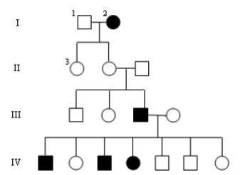
2. a. How many males are there? __________________
b. How many males have hemophilia? ____________
c. How many female are there? _________________
d. How many females have hemophilia? __________
e. What is the genotype of the male and female in
generation 1?
__________________________________

