**DNA Notes Part 2 Name: _______________________**

Big Picture:

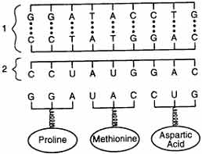

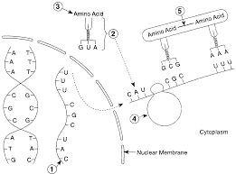The Process:

**Protein Synthesis (The Details)**

The process which makes new proteins. It happens in two stages 1) Transcription and 2) Translation

**Stage 1 = _________________________ DNA 🡪 mRNA**

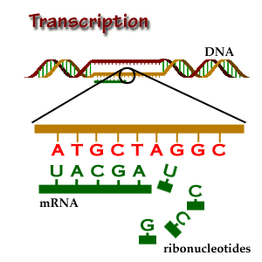This is the process by which mRNA is produced (transcribed) from DNA. It occurs in the ____________________.

The Major Steps:

1. **DNA** gets unzipped by the______________ ***RNA polymerase*.**
2. The *RNA polymerase* reads along one DNA strand and uses it as a template, reading one **DNA triplet** at a time.

1. **mRNA** is produced with the _________________ nucleotides. (Using A, U, C, and G)
2. The polymerase keeps making the **mRNA** until the DNA signals it to stop. Then the mRNA can be _____________removing **introns** and leaving only **exons** to code for proteins. This new mRNA strand now leaves the nucleus and heads to the ____________________ for part two of protein synthesis.

**Stage 2: _________________________ mRNA 🡪 Polypeptide Chain (Protein)**

The synthesis of polypeptides (PROTEINS) by the ribosome using the message carried by the mRNA

**What exactly happens during translation???**

1. 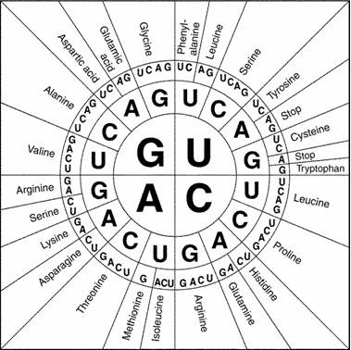The ribosome attaches to the first ____________ of **mRNA**. What is a codon? A _______ base piece of mRNA. Ex) AAU
2. A **tRNA** anticodon matches up to the first codon on the **mRNA** which is called the start codon _______, it also codes for the amino acid ________________________.
3. The **tRNA** is carrying an ___________ __________.

(Remember: These are the monomer for proteins.)

1. 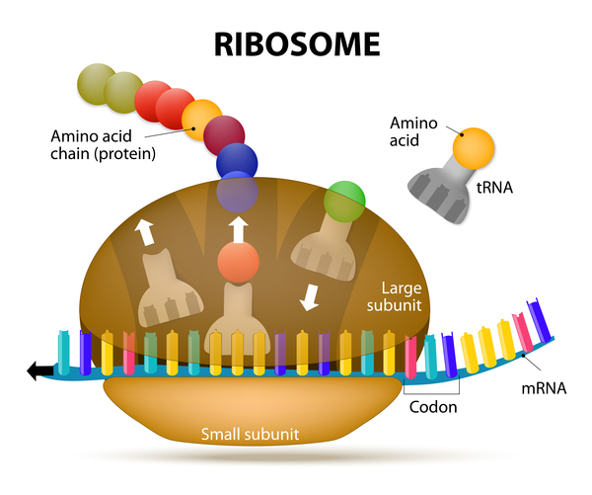The ribosome pulls the **mRNA** through and reads the

next codon and matches up the correct ___________; bringing the next amino acid into line.

1. The ribosome binds the first and second amino acids together, beginning elongation of the ______________________.
2. The **tRNA’s** leave after they “drop off” the amino acids, they can be reused.
3. This process occurs over and over until a stop codon is met. The stop codons are ______, ________, _______

|  |  |  |  |
| --- | --- | --- | --- |
| DNA Triplets | mRNA Codons  (Use A,U,C,G) | Amino Acid  Use the codon chart | tRNA anticodons  These should complement the mRNA |
| TCG |  |  |  |
| CAC |  |  |  |
| GGG |  |  |  |
| CTA |  |  |  |
| AAT |  |  |  |
| TTG |  |  |  |
| TGA |  |  |  |
| CCA |  |  |  |
| TCA |  |  |  |

1. The result is a ________________________ 🡪 **PROTEIN**.

Activity I The Cat Message

MCj04241160000[1]

Directions:

Each DNA triplet represents one letter of the alphabet.

Carefully follow the steps to determine what the cat

is trying to tell you.

Step 1. **Transcribe** the DNA triplets into mRNA codons.

Step 2. Use the chart of mRNA codons to find the correct amino acids.

Step 3. Write the alphabet letter for that amino acid above the appropriate

DNA triplet to **translate** the message.

TAT’ ATC CTT CCC CAG TGA TAT TGA—TGC GTG CTT

CCC CTT TTG CTT TGA TAT ACG ACG CAG CTA CTT!

ACC CGA TAT TGA CGA TAC TAT TTG ACT TGA CTT,

ACC GTG CAG CGA GAG GGG GTG CGA---

GTT CTT TGA TAT TTT CTT CTA TGA GTG TAT AGA?!

**Summary Questions:**

1. Name (complete names) the three types of RNA.

2. What is the sequence of three bases called in mRNA?

3. What is the sequence of three bases called in tRNA?

3. What does the tRNA molecule do?

4. What are the building blocks (the monomer) of proteins?

5. Where does protein synthesis occur?

**When it all goes wrong? Mutations (Chapter 12 Section 4)**



Mutation - ________________________________________________________________________________

Causes can be: 1)

2)

Mutation in a reproductive cell vs. somatic cell:

Gene Mutations: __________________________________________________________________________

Also called ________________________________________.

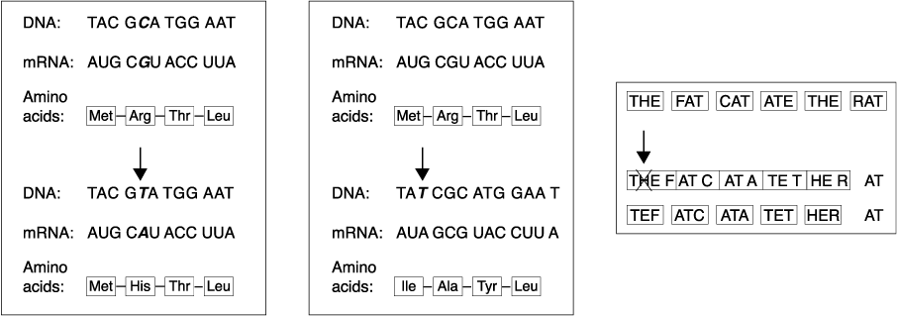

Substitution -

___________________________________________________________________________________________________________________

___________________________________________________________________________________________________________________

Insertion -

_________________________________________________________________________________________________________

_________________________________________________________________________________________________________

Deletion -

_________________________________________________________________________________________________________

_________________________________________________________________________________________________________

_______________Frameshift Mutations __________________ ___________________________________________________

___________________________________________________

Chromosomal Mutations: ______________________________________________________

a) Entire Chromosome Mistakes

What is nondisjunction?

b) Mistakes with a Portion of a Chromosome

Label the diagrams below with the correct mutation: Duplication, Deletion, Inversion, and Translocation

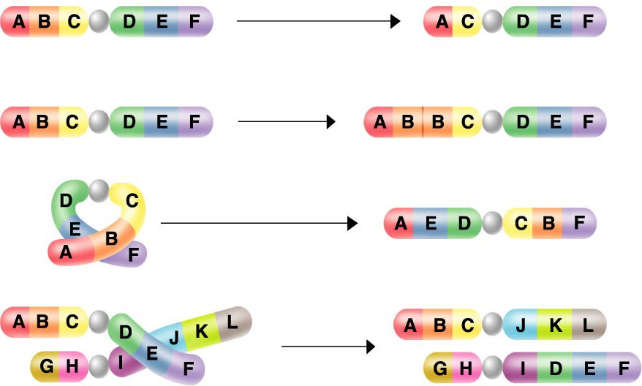

When do chromosomal mutations happen? ___________________________

Now answer questions 1-4 on page 308 in the dragonfly book (Section Assessment)

1.

2.

3.

4.

Online – Go online and look for conditions caused by different mutations. (What it is and what type of mutation it is caused by) A few web pages to get you started:

<http://learn.genetics.utah.edu/content/basics/outcomes/>

<http://learn.genetics.utah.edu/content/basics/diagnose/>

|  |  |
| --- | --- |
| Chromosomal Mutation | Gene Mutations |