Name: ______________________________________ Period: ___________ Date: ______________
EVOLUTION UNIT 1 STUDY GUIDE
Part A. Vocabulary Matching People, Theories and Terms
_____ 1. Artificial Selection a. An organism’s ability to survive and reproduce
_____ 2. Natural Selection b. A physical structure or part of an organism’s anatomy that helps it survive
_____ 3. Abiogenesis c. A behavior that an organism does that helps it survive
_____ 4. Fitness d. Individuals best suited to the environment are the ones that survive and reproduce
_____ 5. Physiological Adaptation e. Theory that living things come from other living things
_____ 6. Spontaneous Generation f. A response of internal body chemistry that helps an organism survive
_____ 7. Biogenesis g. Humans select and breed for the most desirable traits
_____ 8. Structural Adaptation h. Theory that living things comes from non-living things
_____ 9. Behavioral Adaptation i. Another term for spontaneous generation
__________________________________________________________________________________________________
______ 10. Fransisco Redi a. Experimented with broth and found that living things do not come from air
______ 11. Lynn Margulis b. Principle of Acquired Traits and Principle of Use and Disuse
______ 12. Louis Pasteur c. Wrote Principles in Geology stating that the earth’s landscape changes over time
______ 13. Endosymbiont Theory d. Wrote a letter to encourage Darwin in his theory of evolution
______ 14. Jean Baptiste Lamarck e. Experimented with meat and maggots and disproved spontaneous generation
______ 15. Thomas Malthus f. Prokaryotes living in community with other prokaryotes later forming eukaryotes
______ 16. Charles Lyell g. Wrote a book that human population is growing faster than the earth can support
______ 17. Alfred Wallace h. Proposed the Endosymbiont Theory
______ 18. Miller and Urey i. Simulated Earth’s early atmosphere with electric sparks and formed organic compounds
______ 19. Charles Darwin j. Developed his theory of evolution after studying plants and animals around the world
__________________________________________________________________________________________________
_____ 20. Fossil a. Determining the age of a fossil by comparing its placement in rock to other fossils
_____ 21. Radiometric Dating b. Structures that are no longer used by organisms and are usually reduced in size
_____ 22. Relative Dating c. Comparing DNA or amino acid sequences of organisms to determine relationships
_____ 23. Comparative Embryology d. The idea that each living species has descended, with changes, from other species
_____ 24. Comparative Biochemistry e. Comparing early developmental stages of organisms to determine relationships
_____ 25. Vestigial Organs f. No oxygen, no water, poisonous gases, lightning, volcanoes
_____ 26. Descent with Modification g. Determining the age of a fossil by using half-lives of radioactive isotopes
_____ 27. Proposed Components of Early Earth h. Preserved remains or evidence of an organism from long ago
_____ 28. Theory of Evolution i. Organisms change over time AND descended from ancient organisms
Part B. Natural Selection
1. Read the scenario below and write how each of the tenets of natural selection apply to the scenario.
The peppered moths of northern England have two main phenotypes in their gene pool: dark colored and light/pepper colored. Both variations had to compete to survive the bird predators. Prior to England’s Industrial Revolution, the trees in northern England towns were lighter in color. The nocturnal moths rest on the trees during the day; however, bird predators feasted on these dark moths because they were easy to spot, and the frequency of the dark moth in the population was very low. However, after the Industrial Revolution, black smoke from smokestacks polluted the air and darkened the surrounding trees. Over time, the frequency of the dark moths dramatically increased due to being able hide from bird predators more effectively. After the Industrial Revolution the light/peppered colored moths stood out on the trees more and were eaten by predators. Over time, the frequency of the light/peppered colored moths decreased in the area.
How does each of the tenets of natural selection apply to the above scenario of the peppered moths?
- Variation in the Gene Pool: _____________________________________________________________________________
- Organisms over-reproduce: _____________________________________________________________________________
- Struggle for Existence: _________________________________________________________________________________
- Survival of the Fittest: _________________________________________________________________________________
2. Classify each of the following adaptations as structural, behavioral or physiological.
- Thick fur coating in polar bears ______________________________
- Lizards moving onto a rock in the sun when they are cold _________________________________
- When the elephant is overheated, blood vessels in the ear dilate so heat can be released ____________________________
- Animals moving around in herds for protection ______________________________
- Hooked beak for meat-eating birds, useful for tearing flesh ____________________________
- Poison venom of a snake ___________________________________
- The flippers of a penguin ___________________________________
- The sticky tongue of a frog ___________________________________
- Saliva that digests carbohydrates ________________________________
- The woodpecker using a cactus spine to remove insects from a tree _________________________________

Part C. Darwinian Evolution
1. According to evolutionists, put the following organisms in order by numbering 1- 5 as to their development.
______ a. Chemosynthetic anaerobic bacteria
______ b. Unicellular eukaryotes
______ c. Heterotrophic anaerobic bacteria
______ d. Multicellular eukaryotes
______ e. Photosynthetic bacteria releasing oxygen into the air

2. Evolutionary Scientist’s Evidence for the Theory of Evolution:
- Fossil Record
  - The preserved remains of an organism that lived long ago is called a _____________________.
  - Determining the age of a fossil by comparing its placement in rock with that of other fossils in other layers of rock is known as ________________________ dating. This gives an (estimated/more exact) age of the fossil. Circle one.
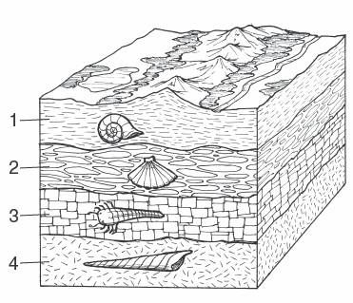
  - By looking at the diagram provided,
draw a red arrow to the fossil that would
be the oldest and a green arrow to the
fossil that would be the youngest.

  - Determining the age of a fossil by using half-lives of isotopes of radioactive elements such as carbon-14 or potassium-40 is known as _________________________ dating. This gives an (estimated/more exact) age of the fossil. Circle one.

- Comparative Embryology
  - Comparing the ______________ stages of development of organisms to show relationships.
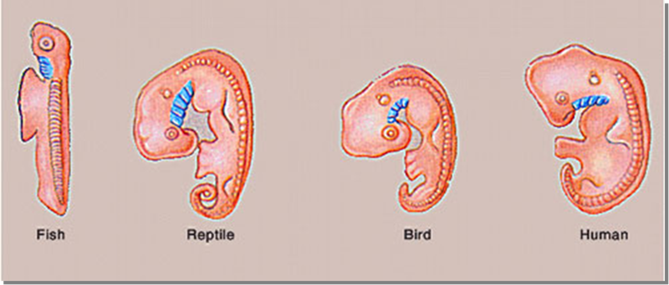

- Comparative Biochemistry
  - Comparing __________ or _______________ _________ sequences of different organisms to show relationships.
  - Use the following chart to circle the differences of the partial amino acid sequences of the protein hemoglobin between four different organisms.
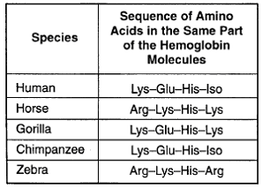
iii. Which organisms have the most number of differences? ______________________________
iv. Which organisms have the least number of differences? ______________________________

- Vestigial Organs
  - Organs that are ________ longer used by an organism and are usually ________________ in size.
  - Name 3 examples of Vestigial Organs: _________________________
_________________________
_________________________

- Homologous Structures and Analogous Structures
  - Picture of Homologous Structures: 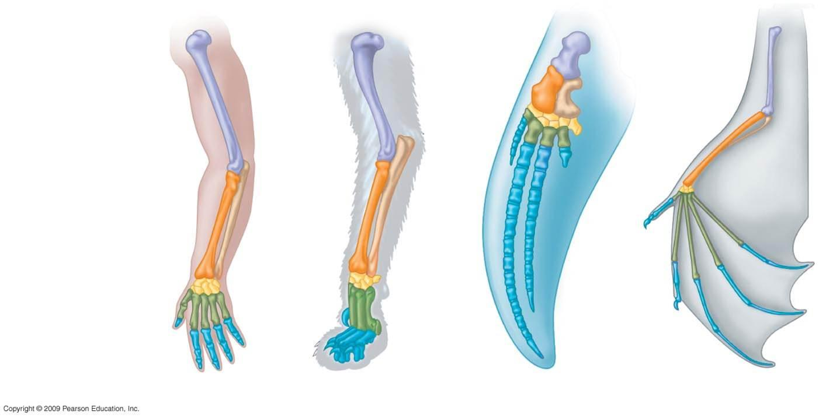
  - Homologous Structures Circle which one applies
Structure: Same or Different
Function: Same or Different
Common Ancestor: Yes or No
4. Gradualism vs. Punctuated Equilibrium
a. The idea that organisms change slowly and steadily over time is known as __________________________.
b. The idea that for most of the time, species are stable. But every now and then there is a disruptive event that promotes rapid change is known as ____________________________________.
c. In the box below, label which change in the bird organisms are represented by gradualism and which is represented by punctuated equilibrium.
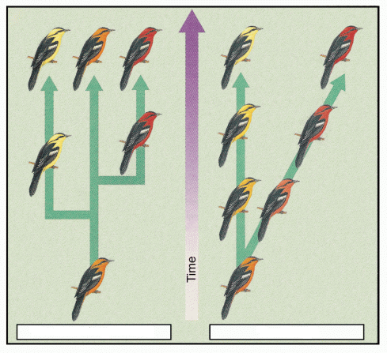

Part C: Old Topic - Cell Transport
- All organisms have basic needs including nutrients and water as well as removing wastes. How does the cell membrane allow the cell to transport these materials into and out of the cell?

- Complete the following chart comparing the various methods of cell transport.
Transport  Method | Active or Passive | Uses ATP - Energy  (Yes or No) | Transport Direction  (high to low OR low to high)
Passive Transport
Diffusion
Osmosis
Active Transport
Endocytosis
Exocytosis

- What material diffuses across the cell membrane during osmosis? _______________________

- Draw a diagram showing how the containers will look after 5 minutes when the two containers are in a state of homeostasis. Explain your answer including a description of homeostasis.

- A human blood cell (1%) solute is placed in salt water (5%) solute.
  - Where is the water more concentrated? (circle one) - inside or outside
  - Which direction will the water move? (circle one) - into or out of the cell
  - What effect will this have on the cell? __cell loses water, shrinks, dehydrates___

- Look at the cross section of a cell membrane of a eukaryotic cell. H+ ions are being pumped from a low concentration to a high concentration. How do you describe this type of transport across the cell membrane?
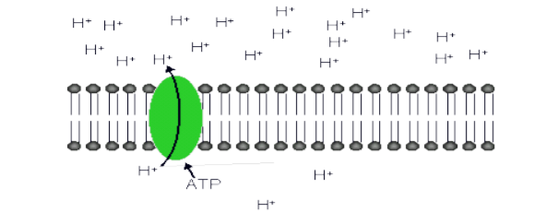
  - active transport
  - passive transport
  - facilitated diffusion
  - co-transport

- Look at the diagram of a cross-section of a cell membrane below. The cell membrane controls movement of materials into and out of the cell. The following particles are moving from high concentration to low concentration and are using a carrier protein. How would you describe this type of movement across the membrane?
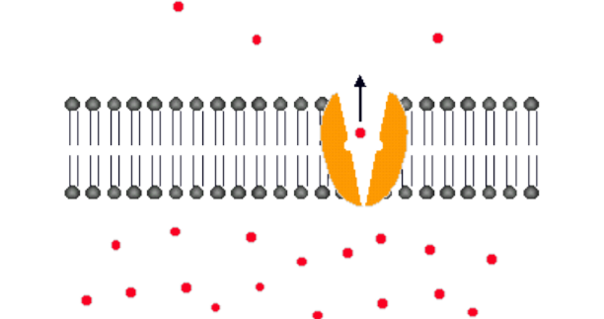

  - simple osmosis
  - active transport
  - simple diffusion
  - facilitated diffusion

- A human blood cell (1%) solute is placed in distilled water (0% - pure water) solute.
  - Where is the water more concentrated? (circle one) - inside or outside
  - Which direction will the water move? (circle one) - into or out of the cell
  - What effect will this have on the cell? __cell gains water, swells_____

- Identify the type of cell transport involved in each of the following descriptions. Use the key provided to indicate your answers.
A. active transport | B. diffusion
C. endocytosis | D. passive transport
E. osmosis | F. exocytosis

Movement of water across a semipermeable membrane down its concentration gradient.
The movement of materials cross a semipermeable membrane down their concentration gradients with the assistance of carrier proteins.
The movement of materials down their concentration gradients.
Pumping of materials across a membrane against their concentration gradients through protein channels.
Intake of small droplets of liquid by endocytosis.
Occurs when a vesicle fuses with the cell membrane releasing the contents to the outside of the cell.
A white blood cell engulfs a harmful bacterium.
Drinking sea water causes the loss of water from cells lining the stomach and intestines.

- Sally took the notes shown below while learning about cells. She forgot to write the name of the cell structure that her class was studying that day. What structure is described in her notes?
• Forms boundary between a cell and the outside environment
• Controls the movement of materials into and out of the cell
• Consists of double layer of phospholipids

- endoplasmic reticulum b. cell membrane c. cell wall d. nucleus

