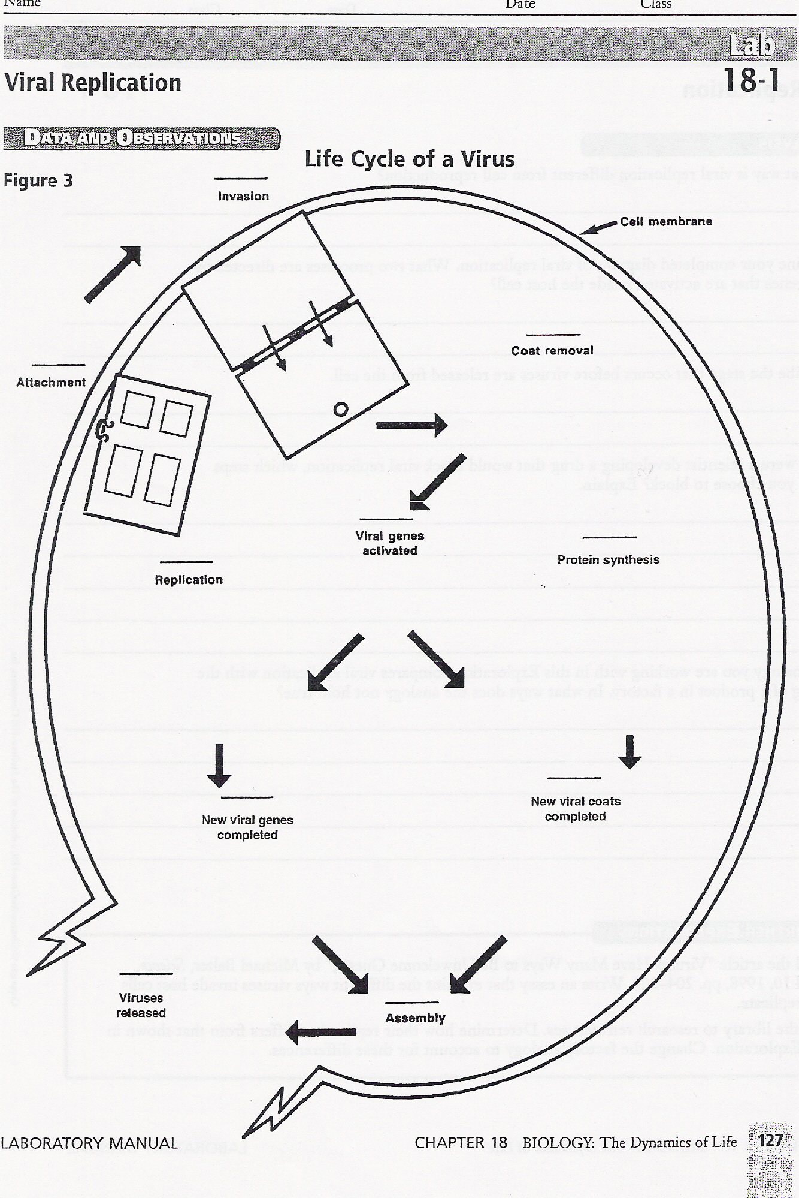

Post-Lab Questions:
- The Viral Cycle represented on the front page is the ____________________ Cycle.
- Write the correct order of each picture for the given viral cycle (Use the picture numbers for writing the order).
- Describe what is happening in each picture of the viral cycle (make sure to write the correct picture # in the box provided):
  - Picture # → ____________________________________________________
__________________________________________________________________
  - Picture # → ____________________________________________________
__________________________________________________________________
  - Picture # → ____________________________________________________
__________________________________________________________________
  - Picture # → ____________________________________________________
__________________________________________________________________
  - Picture # → ____________________________________________________
__________________________________________________________________
Picture # → ____________________________________________________
__________________________________________________________________
  - Picture # → ____________________________________________________
__________________________________________________________________
Picture # → ____________________________________________________
__________________________________________________________________
  - Picture # → ____________________________________________________
__________________________________________________________________
  - Picture # → ____________________________________________________
__________________________________________________________________
- IN DETAIL, describe the difference between this viral cycle created (your answer to #1), and the other viral cycle discussed in class. ________________________________________________________________________
________________________________________________________________________________________________________________________________________________________________________________________________________________________
________________________________________________________________________


