Chemical Reactions and Enzymes Name: ___Key___

Chemical Reaction is the process that changes one set of chemicals, also called the _reactants_, into another set of chemicals, which can be called the _products_.

It is often shown in the form below:

Enzyme

Reactants Products

Chemical reactions always involve the _breaking_ of bonds in the reactants and _formation_ of new bonds in the products.

2 Types of Reactions

1. Condensation (dehydration synthesis)

Dehydration synthesis (also called condensation reaction)

means….. You pull out water to produce one single molecule

from the original two molecules.

Molecule + Molecule 🡪 One Larger Molecule + Water

1. Hydrolysis

Hydrolysis means……. To use water to break one molecule into two smaller molecules.

One Larger Molecule + Water 🡪 Molecule + Molecule

Both of these types of reactions require or are associated with what molecule? _Water_

In each type of reaction you will see molecules of _water_, but it will be a reactant for one and a product for the other.

Let’s look at the reactions……

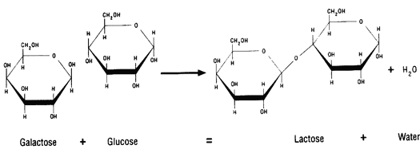

Which reaction do you think this is?_Condensation or Dehydration Synthesis_

Why? Water is pulled out of the two molecules to make a larger molecule

In this case two monosaccharides into one disaccharide.

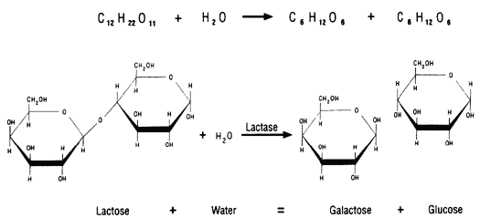

What reaction do you think this is? _Hydrolysis__

Why?

Water is being used to break one larger molecule into two smaller molecules. Disaccharide into two monosaccharides.

Endergonic vs. Exergonic Reactions

Some reactions are Other reactions are

_Endergonic_ _Exergonic__

which means that they which means that they

absorb energy. release energy.

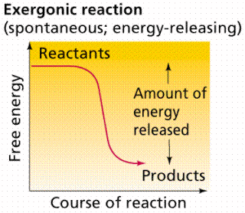

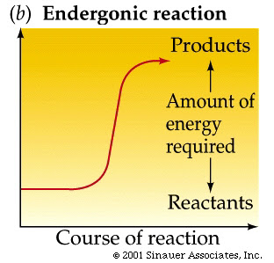

Enzymes (A Special Type Of Protein)

Energy required to get a reaction started is called _Activation_ energy.

Important to Know:

Many of the reactions that are necessary for life to continue happen at a very slow rate.

In order to keep life going, and these reactions happening at the required rate your body using something called a _catalyst_.

_Enzymes_, such as lactase, are a type of catalyst. Enzymes commonly end in –ase (Ex Sucrase)

What is the purpose of an enzyme? To decrease the _activation_ energy required to get a reaction started.

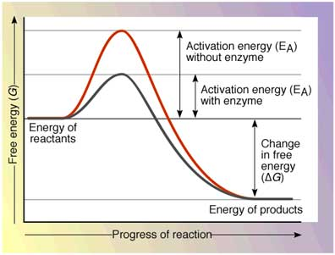

The top of the “hill” is called the transition point, but the reaction does not actually happen until on the way back down. If you decrease the size of the “hill” you also decrease the energy required to begin the reaction.

How does an enzyme do its job?

This is often called a lock and key fit or induced fit model. Each substrate must be able to “fit” into the enzyme active site. Because of this requirement enzymes are very specific for the substrate they work on.

Example: The enzyme lactase breaks down the disaccharide lactose.

What example is shown in this diagram?

Sucrose, the sugar being broken down by the enzyme sucrase.

Enzyme-Substrate Complex

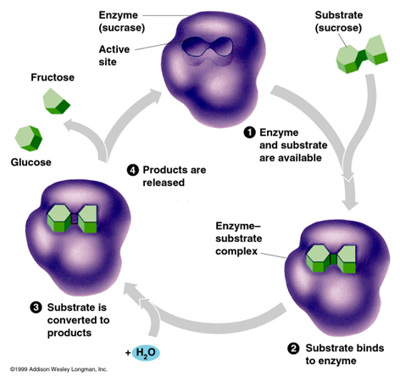

Factors that impact the rate the enzyme functions:

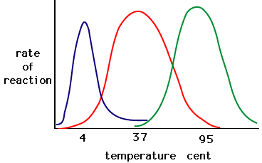1) Temperature

There is an optimal

Temperature for all

Enzymes.

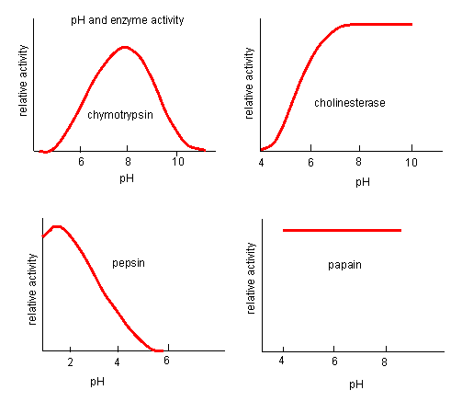

2) pH

Some enzymes work

at a wide range of

pH’s and others will

only work at a

specific pH.

3) Substrate Concentration

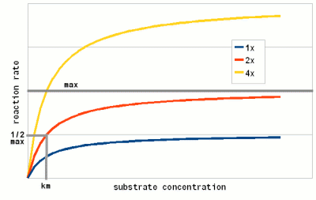Increasing the substrate

that the enzyme works

on will increase the rate of

the reaction up to a

particular point.

Chemical Reactions and Enzymes Name: __________________

Chemical Reaction is the process that changes one set of chemicals, also called the ______________, into another set of chemicals, which can be called the ____________.

It is often shown in the form below:

Enzyme

Reactants Products

Chemical reactions always involve the _______________ of bonds in the reactants and __________ of new bonds in the products.

2 Types of Reactions

1. Condensation (dehydration synthesis)

Dehydration synthesis (also called condensation reaction) means….. You pull out water to

produce ______ larger molecule from the original two molecules.

Molecule + Molecule 🡪 One Larger Molecule + Water

1. Hydrolysis

Hydrolysis means……. To use water to break one molecule into ___________ smaller molecules.

One Larger Molecule + Water 🡪 Molecule + Molecule

Both of these types of reactions require or are associated with what molecule? _______________

In each type of reaction you will see molecules of ________________, but it will be a reactant for one and a product for the other.

Let’s look at the reactions……

Which reaction do you think this is?_____________________________________

Why?



What reaction do you think this is? ________________________

Why? 

Endergonic vs. Exergonic Reactions

Some reactions are ____________ Other reactions are _______________

which means that they absorb energy. which means that they release energy.





Enzymes (A Special Type of Protein)

Energy required to get a reaction started is called _________ energy.

Important to Know:

Many of the reactions that are necessary for life to continue happen at a very slow rate.

In order to keep life going, and these reactions happening at the required rate your body using something called a ___________.

_______________________, such as lactase, are a type of catalyst.

What is the purpose of an enzyme? To decrease the ___________________ energy required to get a reaction started.

The top of the “hill” is called the transition point, but the reaction does not actually happen until on the way back down.

How does an enzyme do its job?

This is often called a lock and key fit or induced fit model. Each substrate must be able to “fit” into the enzyme active site. Because of this requirement enzymes are very specific for the substrate they work on.

Example:

What example is shown in this diagram?

Enzyme-Substrate Complex



**Factors that impact the rate the enzyme functions:**

**1)**



**2)**

**3)**



**Notes Review Questions:**

1. What are the two types of reactions?

2. What is the difference between these two reactions?

3. What term is given to the materials going into a reaction (on the left side of the arrow)?

4. What term is given to the materials coming out of the reaction (on the right side of the arrow)?

5. When a reaction is energy releasing it is called?

6. When a reaction is energy absorbing it is called?

7. What is the purpose of an enzyme?

8. What type of macromolecule is an enzyme?

9. Looking at the enzyme-substrate complex diagram, write out the chemical equation for the reaction occurring in the diagram?

_______________________________ 🡪 _____________________________

10. What type of reaction was this (condensation or hydrolysis), how did you know?

11. What factors impact the rate at which an enzyme works?