**Basics of a Plant:** (Kingdom Plantae)

____________, Multicellular, Cell Wall Made of ______________, and Carry out ___________________ using Chlorophyll (Autotrophs).

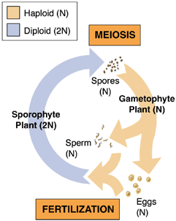**Reproduction**: _________________ of Generations between _______________ (2N-diploid) and ________________ (1N-haploid)

**Requirements for Survival:** Water and Minerals, Sunlight, Gas Exchange, and a Movement System for Water and Nutrients

Photosynthesis Equation:

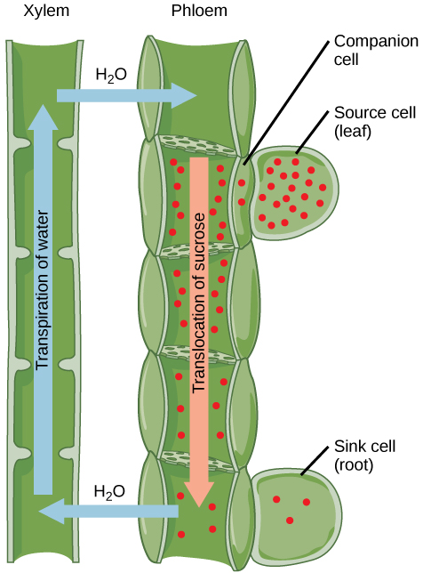**Plant Parts:**

Vascular Tissue (Adaptation #1) - Transport system to move ________ and __________ throughout the plant. This allowed the plant to grow taller.

**(Terms to Know: Root, Leaves, Stems, Veins)**

_________ (Adaptation #2)- Allowed plants to reproduce without water.

**(Terms to Know: Cones, Flowers, Pollen Grain, Pollination, Seed, Embryo, Seed Coat)**

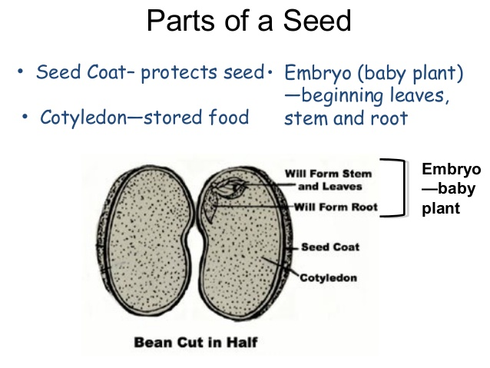

**Flower and Fruit (**Adaptation #3) – Fruit is protection for the seed and enticement for animals, providing another method of seed dispersal. Flowers are fragrant and colorful to encourage pollination.

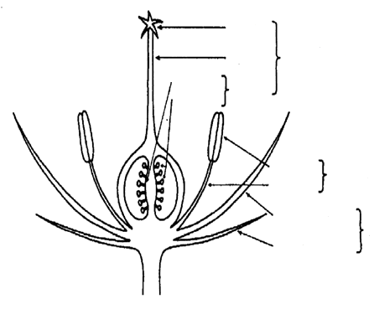

**Evolution of Plants:**

*Green Algae*

*Moss and Their Relatives*

*Cone-bearing Plants: Pine Tree*

*Ferns and Their Relatives*

*Flowering and Fruiting Plants: Apple Tree*

____________________

____________________

____________________

The ancestor to modern plants was __________, kingdom __________.

Plants can be categorized into four different divisions:

1. _______________
2. Pterophyta, ____________, and Lycophyta
3. _________________ (Gymnosperms)
4. _________________ (Angiosperms)

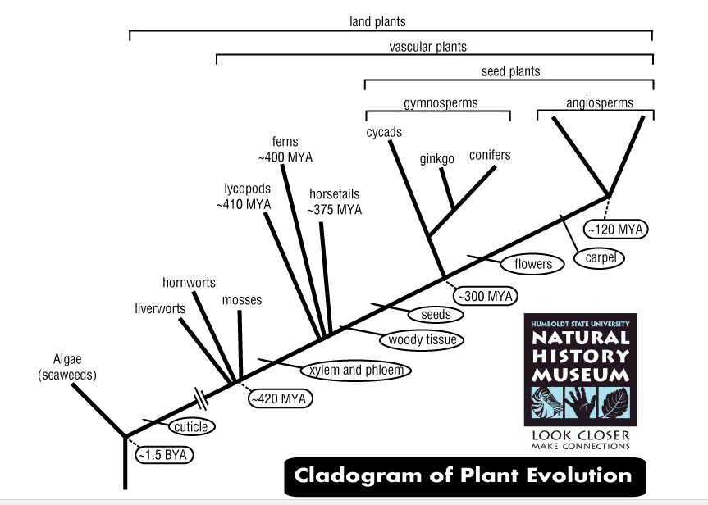

1. List the adaptations from earliest to most recent:
2. What are the different types of gymnosperms?
3. How many groups of vascular plants are there?
4. What is the common ancestor to modern day plants?
5. Based on this cladogram all plants can be found living on

______________________.

Key Characteristics of each group:

|  |  |  |
| --- | --- | --- |
| Category | Characteristics | Examples |
| Bryophytes | Seedless and ___________  Depend on ________ for reproduction  No _____, rhizoids instead | _________, Liverworts, and Hornworts |
| Pterophyta, Arthrophyta, and Lycophyta | Seedless, but do have _____________ tissue (xylem and phloem) | Club Moss, Horsetails, and __________ |
| Coniferophyta (Gymnosperms) | ____________ Tissue and seeds  ________ for reproduction “Naked Seeds” | Gnetophytes, Cycads, Ginkgoes, and _________ |
| Anthophyta (Angiosperms) | ________ Tissue and seeds  _________ and ________ for reproduction  ______cots or ___cots  woody or herbaceous  _________, biennials, ______________ | Apple tree  Azalea Bush  Lily  Sunflowers |



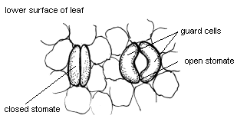**Other Plant Adaptations and Tropisms:**

**__________** – Opens just enough to exchange gases, closes to

ensure that they do not lose excess water.

**____________** – Does not grow due to poor temperature and water conditions.

**Hormones**

Auxins – Stimulates cell ___________

Cytokinins – determines plant ___________

Gibberelins – increases the _______ of plants (flowers and fruits)

Ethylene – Stimulates ___________ of fruits.

**Tropisms**

________________ – Plant grows and bends towards the sun

________________ – Roots grow down no matter the direction they

leave the seed.

________________ - Plant response to touch

__________________ – Short v. Long Day Plants (Seasonal plants)