Biology Genetics Test Review Guide Name: ______________________________

_____ | heredity | 1)diagram used by biologists to predict the outcome of a genetic cross  2)refers to an individual with two different alleles for a trait  3)condition in which both alleles for a gene are expressed when present  4)refers to an individual with two identical alleles for a trait  5)an alternative form of a gene  6)condition in which a trait in an individual is intermediate between the phenotype of its two parents  7)the offspring from crosses among individuals of the F1 generation  8)the first two individuals that mate in a genetic cross  9)characteristic of an organism that is influenced by several genes  10)genetic trait that is expressed when it's allele is homozygous or heterozygous  11)genetic trait that is not expressed when the contrasting form of the trait is present  12)a genetic cross of an individual whose phenotype is dominant but whose genotype is unknown  13)study of heredity  14)the existence of more than two alleles  15)displaying only one form of a particular trait in offspring  16)cross involving one pair of contrasting traits  17)the first offspring from a cross of two varieties in the parental(P) generation  18)transmission of genetic traits from parent to offspring  19)the likelihood that a specific event will occur  20)observable characteristics of an organism  21)the genetic makeup of an organism as indicated by its set of alleles
_____ | genetics
_____ | monohybrid breeding
_____ | true-breeding
_____ | allele
_____ | dominant
_____ | recessive
_____ | homozygous
_____ | heterozygous
_____ | genotype
_____ | phenotype
_____ | punnett square
_____ | test cross
_____ | probability
_____ | codominance
_____ | multiple alleles
_____ | polygenic trait
_____ | P generation
_____ | F1 generation
_____ | F2 generation
_____ | incomplete dominance
Who was Mendel? _______________________________________________________________________________
_______________________________________________________________________________________________
_______________________________________________________________________________________________

Explain and Apply Each Law

1. Law of Dominance

2. Law of Segregation

3. Law of Independent Assortment

Punnett Square Practice
- In guinea pigs, black color is dominant over white.
  - Cross a homogeneous black pig with a white pig & give the results for the possible offspring.

Phenotypic ratio:

Genotypic ratio:

  - Explain how two black guinea pigs can have a white offspring.

- When yellow canaries (Y) are crossed with white canaries (y), cream-colored offspring are produced.
  - What type of inheritance does this trait have? _____________________________
  - What are the genotypes and phenotypes for the three options for canary coloring?

  - Cross a yellow male with a cream-colored female &
give the offspring results.

  - Can a pet storeowner mate a cream-colored male and a white female to obtain a yellow offspring? Explain.

- When a black hamsters and a white hamsters are mated a spotted hamster are produced.
  - What type of inheritance does this trait have? _____________________________
  - What are the genotypes and phenotypes for the three options for hamster coloring?

  - Cross a spotted male with a white female & give the offspring results.

Phenotypic Ratio:

Genotypic Ratio:

- A woman with type AB blood marries a man with type B blood. They have a child with type A blood.
  - What type of inheritance does this trait have? _____________________________
  - What are the alleles that can be used for this trait? ________________________________
  - What are the genotypes for the mother and father? Explain.

  - Provide the following ratios:
Phenotypic Ratio:

Genotypic Ratio:

  - Can they have a child with type O blood? Explain.
- A couple has four children. Their first child has type A blood, the second type O blood, the third type AB blood, and the fourth has type B blood.
  - What are the genotypes and phenotypes of the parents? Explain

  - What is the probability that their next child will be type O blood?
Explain.

- A woman who is heterozygous for hemophilia, which is sex-linked,
marries a normal man.
What will be the possible phenotype ratio of their children?

- A woman who is a carrier for hemophilia marries a hemophiliac man.
What will be their children’s’ possible phenotypes?

- Brown (B) fur color is dominant to white (b) and long fur length (L) is dominant to short (l). Complete a Punnett square for the following dihybrid (two traits) cross.
[**Hint: your square should have 4 boxes across and 4 boxes down, each gamete will have one of each letter]
BbLL X bbLl
- What are the phenotypes of the two parents? BbLL = bbLl=
- After you complete your Punnett square, provide the phenotypic ratio for all the offspring.

______ Brown long fur

______ Brown short fur

______ White long fur

______ White short fur

Pedigrees
1. What is the purpose of a pedigree?

2. Males are represented by a ________________ shape and females by a _____________ shape.

3. Those that are affected by the disorder will be ________________. Will all carriers be ½ shaded? _______________

For Questions 1-9, use the pedigree chart shown below. Some of the labels may be used more than once.

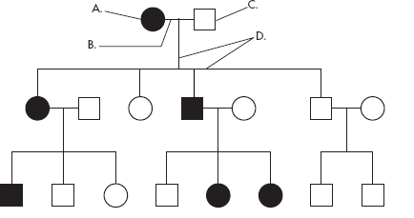
________ 1. A male
2. A female
_________ 3. A marriage
4. A person who expresses the trait
5. A person who does not express the trait
6. A connection between parents and offspring
________ 7. How many generations are shown on this chart?

Assuming the chart above is tracing the dominant trait of "White Forelock (F)" through the family. F is a tuft of white hair on the forehead.
________8. What is the most likely genotype of individual “A”? (FF, Ff or ff?)
________9. What is the most likely genotype of individual “C”? (FF, Ff or ff?)

Karyotypes
Look at the karyotype in Figure 1 below. Notice the two sex chromosomes, pair number 23, do not look alike. They are different because this karyotype is of a male, and a male has an X and a Y chromosome. Circle the Y chromosome in the Karyotype below.
How many chromosomes does a normal person have? 23 or 46

Which chromosome is the longest and has the most genes? 1 or 21

Which chromosome is the shortest and has the fewest genes? 2 or 22

In a normal karyotype how many
autosomal chromosomes are there? _______ Sex chromosomes? _______

Look at the karyotype labeled figure 4. Do you see any chromosomal abnormalities? YES NO

What chromosomes are abnormal?
AUTOSOME SEX

Identify the disorder in karyotype Figure 4.

___________________________________

Look at the karyotype to the left is it?
MALE or FEMALE
NORMAL or ABNORMAL

Identify the disorder in karyotype Figure 5.

_________________________________________

Nondisjuction is a chromosomal mutation that occurs
during meiosis. Definition of Nondisjuction.
_____________________________________________
_____________________________________________
_____________________________________________
One type of nondisjunction mutation is trisomy 21. What is another name for it? ________________
What disorder does the person below have?
______________
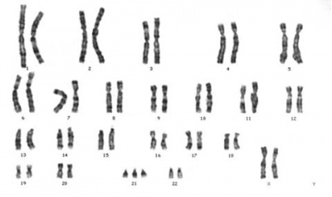
Are they? MALE FEMALE

