**DNA: The Double Helix**

**The Discovery of DNA**

Chapter 12.1 in the Dragonfly Book Questions

Griffith’s Transformation experiment:

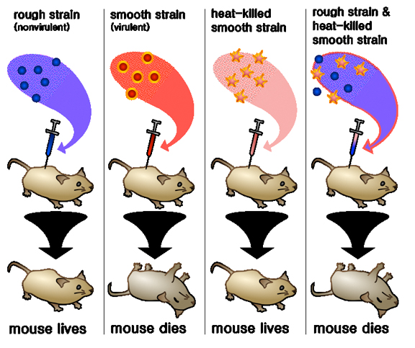

1. What was Griffith trying to learn when he set up this experiment?

How does bacteria make you sick (Pneumonia)

1. How did Griffith show that the disease-causing bacteria were killed by the heat? He injected the heat-killed harmful bacteria into the mice and it did not make the mice sick.
2. What result was Griffith expecting when he injected the mixture of live harmless bacteria and heat killed bacteria?

He expected the mice to live because by themselves, the harmless live bacteria and the heat-killed bacteria did not make the mice sick. He was surprised when, after mixing these two bacteria together, the mice got sick and died.

Hershey and Chase’s experimental design.

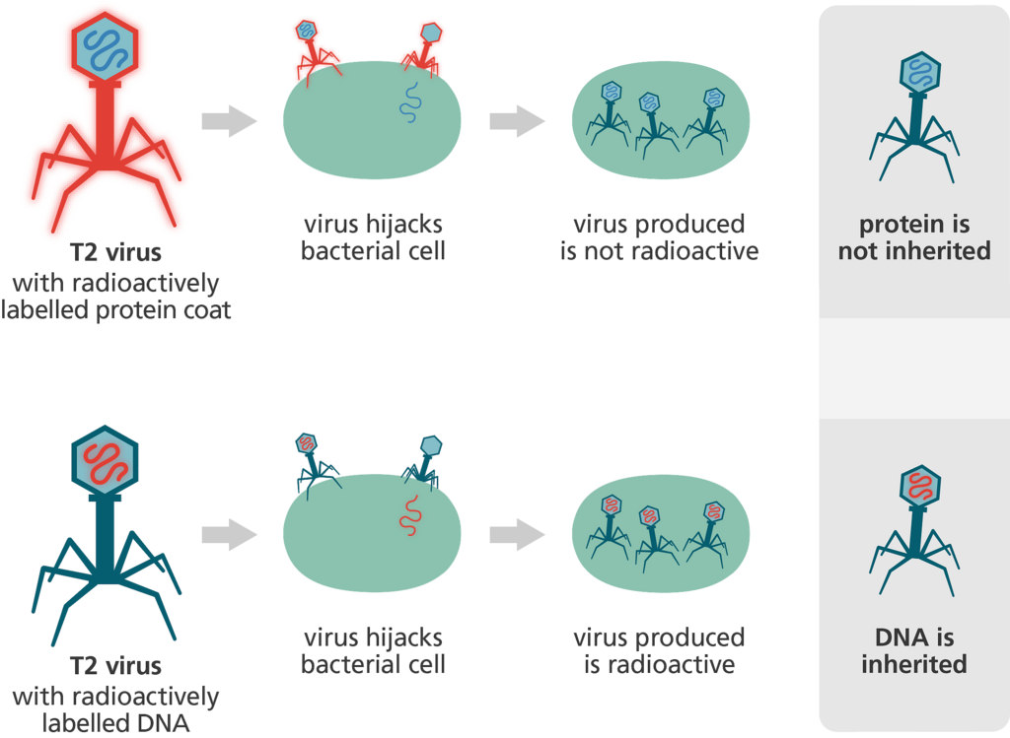

1. How were they able to determine whether bacteriophages injected DNA or protein into bacteria?

Hershey and Chase radioactively marked the protein part of the virus (bacteriophage) with S-35 radioactive sulfur isotope and the DNA part of the virus with P-35 radioactive phosphorus isotope. Whichever isotope was found in the bacteria was what the virus injected or transferred into the bacteria.

1. What would you expect if a bacteriophage injected protein into a bacterial cell? To find the radioactive sulfur in the bacteria.
2. What part of the virus did the Hershey-Chase experiment show has entered the bacteria? It showed the radioactive phosphorus in the bacteria, showing DNA was the factor that was transferred.

# Chargaff’s Rules

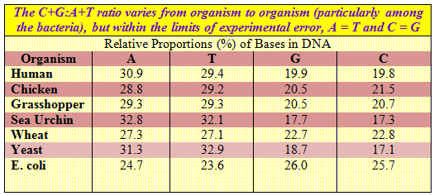

`

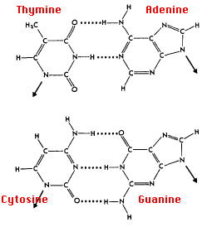

# 1. What did Chargaff’s studies reveal about the relationship between nucleotides? The % of thymine = % of adenine and the % of guanine = % of cytosine.

# Rosalind Franklin

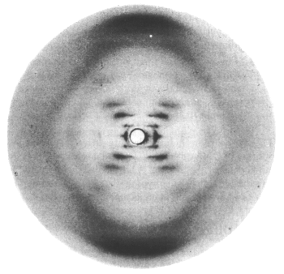

1. What technique did Rosalind Franklin use to study DNA?

x-ray diffraction techniques

1. What clues were gained from her research? That DNA was a helical molecule, that it was composed of two strands, and the nucleotides were in the center.

# Watson and Crick

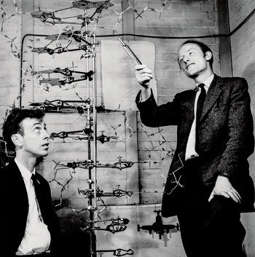 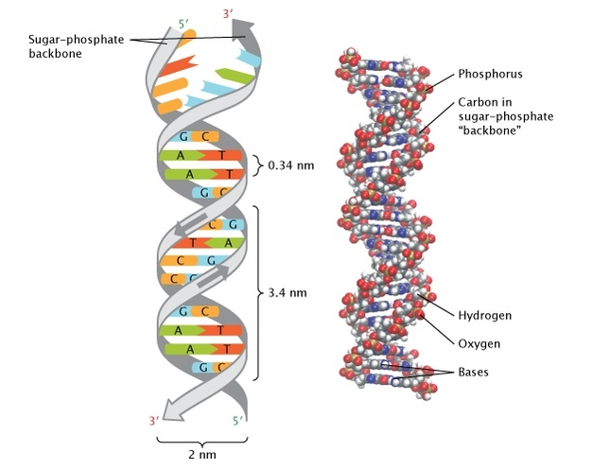

1. What did Watson and Crick contribute to the study of DNA?

**They** used Franklin’s x-ray pictures of DNA as clues and developed a model of a strand of DNA. They are credited with realizing DNA was a double helix (twisted ladder), with alternating deoxyribose sugar and phosphate making up the sides of the “ladder” and nitrogen base pairs linked by hydrogen bonds making up the rungs of the “ladder”.

Nucleotides

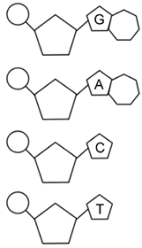**What is DNA???**

P

* Stands for Deoxyribonucleic acid

Sugar

* The monomer for DNA is the **nucleotide**

which has 3 parts

* + Deoxyribose Sugar

P

* + Phosphate

Sugar

* + One of four different nitrogen bases
* DNA is your “genetic” information, which

P

is pass from one generation to another.

Sugar

* DNA is present in ALL LIVING THINGS

Examples:

P

Sugar

**The Structure of DNA: What does DNA Look Like???**

* Classic “Double Helix” Shape – **Watson & Crick**
* Sugar and phosphate alternate to form the backbone (sides) of the “twisted ladder”
* This backbone is said to run **antiparallel**, which means both strands are parallel to each other but runs in an opposite direction.
* 4 major nitrogenous bases that form the rungs of the “ladder” –

Adenine, Thymine, Cytosine, Guanine

* **Chargaff’s Rule: A** always pairs with **T**

**C** always pairs with **G**

We call these complementary bases.

* These complementary bases are attached to each other in the middle by **weak hydrogen bonds**, which can be easily broken when needed.

Why? DNA must unzip for replication and protein synthesis to occur

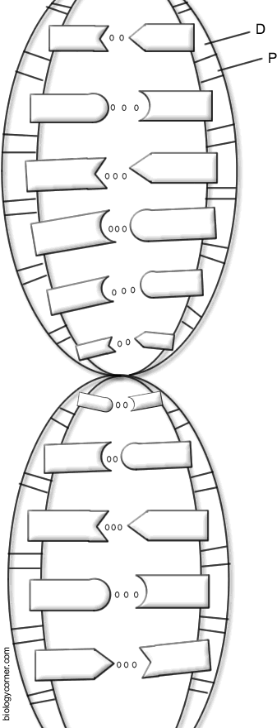

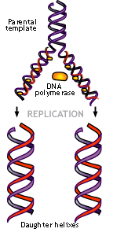**DNA REPLICATION**

**Why Replicate???** In preparation for cell division, a cell must duplicate its genetic info (DNA) to pass on to the new daughter cells. What part of the cell cycle? **Interphase (S phase)**

**Where does this happen?** In eukaryotes this occurs in the nucleus

of a cell.

**How does replication happen? (How does DNA copy itself?)**

1. The DNA unwinds to make the process easier.
2. An **enzyme called helicase** binds to the DNA strand.
3. The enzyme “unzips” the DNA strand – at the weak hydrogen bonds.
4. **DNA polymerase (another enzyme!)** moves along the DNA and it constructs a new strand that matches each of the old strands. Matches the nucleotides **A – T** and **G – C**.

The result is 2 new identical DNA molecules – one from the parent strand and one new strand.

We call this process **Semi-Conservative** because each of the two

strands is ½ new and ½ old genetic information.

**Practice with Replication**

Below are DNA strands.

1) Replicate the complementary DNA strand.

2) Color the original strand red and the new strand green

|  |
| --- |
| Original Strands (In Red)  **A T G C A A A T T G C T C A C** **C G G**  **T A C G T T T A A C G A G T G G C C** |
| 1) Original Strands are Separated by Helicase (In Red)  2) Complementary Base Pairs Match Up (In Green) Using DNA polymerase  **A T G C A A A T T G C T C A C – ½ Old Material**  **T A C G T T T A A C G A G T G – ½ New Material**  **A T G C A A A T T G C T C A C – ½ New Material**  **T A C G T T T A A C G A G T G – ½ Old Material** |

**DNA History, Structure, and Replication Review Questions**

1. Griffith’s experiment with mice concluded that bacteria could be __transformed__ from harmless to disease-causing by an unknown factor.

2. Hershey and Chase used bacteriophages (viruses) to discover _DNA__ was used to transfer information from the virus to the bacteria.

3. What contributions did Rosalind Franklin make towards the discovery of DNA? Name at least two.

- Shape was a spiral

- Nitrogen Bases were near the center

- It was two strands

4. What is the name given to DNA by Watson and Crick? Double Helix

5. What does DNA stand for? Deoxyribonucleic Acid

6. DNA can be found in the _nucleus__ of all cells (where is its home).

7. What is the monomer (building block) that makes up the polymer DNA? Nucleotide

8. What are the three parts of the monomer?

- 5 Carbon Sugar - Phosphate Group - 1 of 4 Nitrogen Bases

9. When DNA is compared to a ladder, what 2 components make up the vertical portion of the ladder (Backbone)? Sugar and Phosphate

10. What makes up the horizontal “rungs” steps of the ladder? Nitrogen Bases

11. What are the names of the nitrogen bases and their compliments?(Which bases pair together?) Adenine – Thymine and Cytosine - Guanine

12. If you were replicating the following strand of DNA what would be its complementary strand?

A T C G G C A T T A A A G C T A T

T A G C C G T A A T T T C G A T A

13. The process of a cell duplicating (copying) its genetic information is called _DNA_ __Replication__.

14. During which phase of the cell cycle does replication take place? Interphase (S Phase)

15. At the end of the replication process you have 2 identical strands of DNA…each strand is made up of one __Old_ (original) strand and one __New__ strand.

16.What protein (enzyme) is used to unzip the strands of DNA? Helicase

17. What protein (enzyme) is used to bring in the new nucleotides during DNA replication? DNA polymerase

RNA: Ribonucleic Acid

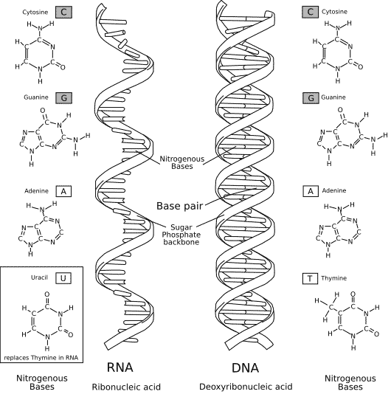

**How is RNA different from DNA???**

1. Has a ribose instead of a deoxyribose (sugar backbone)
2. Single Stranded
3. Contains Uracil ( U ) instead of Thymine

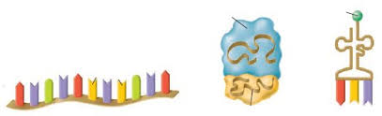**The THREE Types of RNA**

**mRNA** = (messenger) codes for polypeptides

**rRNA** = (ribosomal) makes up ribosomes.

RIBOSOMES are the protein builders!!!

**tRNA** = (transfer) brings the amino acids to the ribosome during protein synthesis

**DNA v. RNA Comparison**

|  |  |  |
| --- | --- | --- |
|  | **DNA** | **RNA** |
| Name |  |  |
| Number of Strands |  |  |
| Types |  |  |
| Nitrogen Bases |  |  |
| Sugars |  |  |
| Locations in the Cell |  |  |
| Functions |  |  |