**DNA: The Double Helix**

**The Discovery of DNA**

Chapter 12.1 in the Dragonfly Book Questions

Griffith’s Transformation experiment:

1. What was Griffith trying to learn when he set up this experiment?
2. How did Griffith show that the disease-causing bacteria were killed by the heat?
3. What result was Griffith expecting when he injected the mixture of live harmless bacteria and heat killed bacteria?

Hershey and Chase’s experimental design.

1. How were they able to determine whether bacteriophages injected DNA or protein into bacteria?
2. What would you expect if a bacteriophage injected protein into a bacterial cell?
3. What part of the virus did the Hershey-Chase experiment show has entered the bacteria?

# Chargaff’s Rules

# 1. What did Chargaff’s studies reveal about the relationship between nucleotides?

# Rosalind Franklin

1. What technique did Rosalind Franklin use to study DNA?
2. What clues were gained from her research?

# Watson and Crick

1. What did Watson and Crick contribute to the study of DNA?

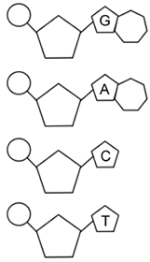**What is DNA???**

* Stands for ________________________ ______
* The monomer for DNA is the **nucleotide** which has 3 parts
  + ___________________________________
  + ___________________________________
  + ___________________________________
* DNA is your “genetic” information, which is pass from one

generation to another.

* DNA is present in _________ LIVING THINGS

**The Structure of DNA: What does DNA Look Like???**

* Classic “___________ _________” Shape – **Watson & Crick**
* _____________ and _______________ alternate to form the

backbone (sides) of the “twisted ladder”

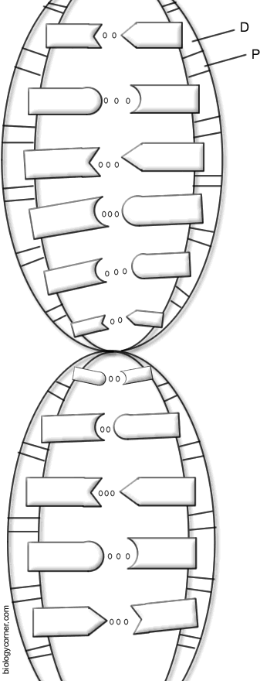This backbone is said to run **antiparallel**, which

means both strands are parallel to each other

but runs in an _______________direction.

* 4 major nitrogenous bases that form the rungs

of the “ladder” –

_________________, ____________________,

_________________, ____________________

* **Chargaff’s Rule: A** always pairs with **T**

**C** always pairs with **G**

We call these _________________ bases.

* These complementary bases are attached to

each other in the middle by **weak ___________________**

**bonds**, which can be easily broken when needed.

Why? DNA must unzip for replication

and protein synthesis to occur

**DNA REPLICATION**

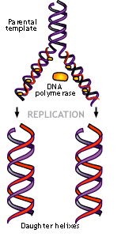

**Why Replicate???** In preparation for _______ ____________, a cell must duplicate its genetic info (DNA) to pass on to the new daughter cells. What part of the cell cycle? **Interphase (S phase)**

**Where does this happen?** In eukaryotes this occurs in the _________________ of a cell.

**How does replication happen? (How does DNA copy itself?)**

* The DNA unwinds to make the process easier.
* An **enzyme called helicase** binds to the DNA strand.
* The enzyme “_____________” the DNA strand – at the weak _______________ bonds.
* **DNA polymerase (another enzyme!)** moves along the DNA and it constructs a new strand that matches each of the old strands. Matches the nucleotides **__________** and **__________**.

The result is 2 new __________________ DNA molecules – one from the _____________ strand and one ______________ strand.

We call this process **Semi-Conservative** because each of the two strands is ½ ________and ½ _______

genetic information.

**Practice with Replication**

Below are DNA strands. 1) Replicate the complementary DNA strand.

2) Color the original strand red and the new strand green

|  |
| --- |
| Original Strands (In Red)  A T G C A A A T T G C T C A C C G G G G A T C A G C A C C G G  T A C G T T T A A C G A G T G G C C C C T A G T C G T G G C C |
| Original Strands are Separated by Helicase (In Red) |
| Complementary Base Pairs Match Up (In Green) |

**DNA History, Structure, and Replication Review Questions**

1. Griffith’s experiment with mice concluded that bacteria could be ________________ from harmless to disease-causing by an unknown factor.

2. Hershey and Chase used bacteriophages (viruses) to discover ___________ was used to transfer information from the virus to the bacteria.

3. What contributions did Rosalind Franklin make towards the discovery of DNA? Name at least two.

-

-

4. What is the name given to DNA by Watson and Crick?

5. What does DNA stand for?

6. DNA can be found in the ____________ of all cells (where is its home).

7. What is the monomer (building block) that makes up the polymer DNA?

8. What are the three parts of the monomer?

- - -

9. When DNA is compared to a ladder, what 2 components make up the vertical portion of the ladder (Backbone)?

10. What makes up the horizontal “rungs” steps of the ladder?

11. What are the names of the nitrogen bases and their compliments?(Which bases pair together?)

12. If you were replicating the following strand of DNA what would be its complementary strand?

A T C G G C A T T A A A G C T A T

13. The process of a cell duplicating (copying) its genetic information is called ____ _____________.

14. During which phase of the cell cycle does replication take place?

15. At the end of the replication process you have 2 identical strands of DNA…each strand is made up of one _________ (original) strand and one _________ strand.

16.What protein (enzyme) is used to unzip the strands of DNA?

17. What protein (enzyme) is used to bring in the new nucleotides during DNA replication?

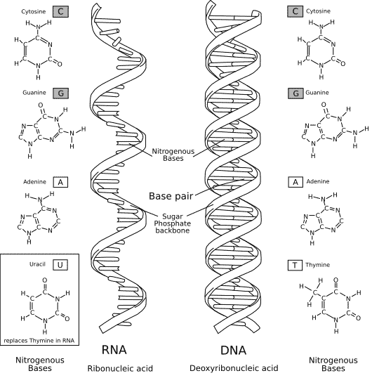**RNA: Ribonucleic Acid**

**How is RNA different from DNA???**

* Has a ____________ instead of a deoxyribose (sugar backbone)
* ___________ Stranded
* Contains _____________( U ) instead of Thymine

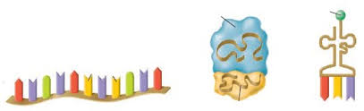**The THREE Types of RNA**

**mRNA** = (_______________) codes for polypeptides

**rRNA** = (___________________) makes up ribosomes.

RIBOSOMES are the protein builders!!!

**tRNA** = (____________) brings the amino acids to the ribosome during protein synthesis

Label Each Type of RNA

**DNA v. RNA Comparison**

|  |  |  |
| --- | --- | --- |
|  | **DNA** | **RNA** |
| Name |  |  |
| Number of Strands |  |  |
| Types |  |  |
| Nitrogen Bases |  |  |
| Sugars |  |  |
| Locations in the Cell |  |  |
| Functions |  |  |