Biology Lab Activity – Simulating Mitosis with “Pop Beads” Name: ______________________________
Introduction: Mitosis is the process of one cell dividing to produce two new (daughter) cells that are identical to the original cell. In other words, each new cell is an “exact” copy of the original parent cell. Mitosis is divided into 4 stages: prophase, metaphase, anaphase, and telophase. Before a cell begins mitosis, it spends most of its life in a stage of the cell cycle called interphase. During interphase, DNA is copied and the cell prepares for mitosis.
Instructions: In this activity you will use chromosome simulation kits (“Pop Beads”) to investigate the process of mitosis. Your kit should include two strands of beads of one color and two strands of a second color along with magnetic pieces to represent the centromeres. Each strand of beads represents a single chromosome. Answer the questions in the space provided as you complete move through each stage of mitosis.

Mitosis and the Cell Cycle
Interphase
Use a piece of string to form a large circle on your table. This circle will represent the cell membrane in this activity. Use a second, smaller piece of string to make a slightly smaller circle. This circle will represent the nucleus. Place one strand of beads (of each color) near the center of your nucleus. Before mitosis can begin, DNA is copied and each chromosome, originally composed of one strand, will be duplicated so that it is now made of two separate strands connected by a centromere. Simulate DNA replication by bringing the magnetic centromere region of one strand of beads in contact with the centromere region of the other strand of beads (of the same color). Repeat with the second chromosome. Sketch what you see on your desk right now in the box to the right.

Questions: What important cellular event takes place during interphase?

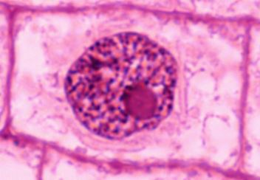
In what way does your desk not look like the real images of cells in interphase?

Mitosis (4 Steps)
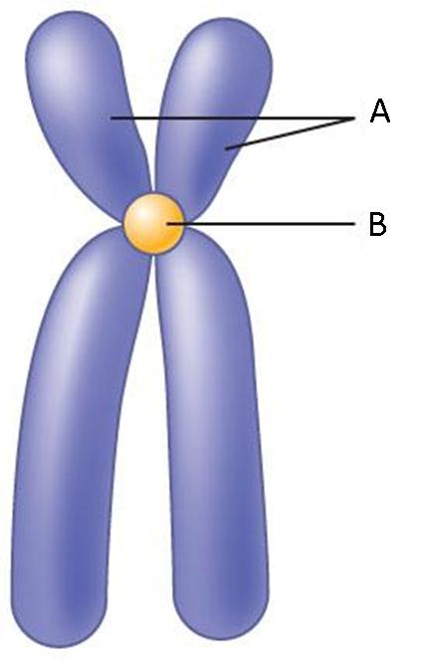
Step 1 - Prophase
Prophase is the first stage of mitosis. During prophase, chromatin DNA condenses into a chromosome structure. Under the microscope, duplicated chromosomes resemble small, twisted “X’s” much like they do in your “cell” right now. Each half of the chromosome is called a sister chromatid and they can first be seen during prophase. The centromere holds both sister chromatids together in a chromosome. (Label your chromosomes seen to the right)

Next, the nuclear membrane begins to break apart and the cell’s nucleolus disappears. Finally, the spindle begins to form on either side of the cell attached to the centrioles of the animal cell. The centrioles are responsible for the proper division of the genetic information during mitosis.

Sketch what you see on your desk right now in the box to the right.

Questions: Which term is used to describe one half of a duplicated chromosome?

What organelle is responsible for division of the chromosomes?

Step 2 – Metaphase
During metaphase, the chromosomes attach to the spindle at their centromere. The chromosomes are “pulled” to the middle of the cell at the equator. If you have not already done so, move your chromosomes to the middle of the cell to model the events of metaphase.
Sketch what you see on your desk right now in the box to the right.

Question: What is the middle of the cell called?

Where do the spindle fibers attach to the DNA at?

Step 3- Anaphase
During anaphase, the sister chromatids of each chromosome separate at the centromere and begin moving to opposite ends of the cell. Each sister chromatid is “pulled” to the opposite side of the cell by the spindle and now are called chromosomes. Model the events of anaphase by pulling your chromosomes apart and moving the sister chromatids away from each other towards opposite ends of the cell. Sketch what you see on your desk right now in the box to the right.

Questions: Are the structures that begin moving to opposite ends of the cell during anaphase called chromosomes or sister chromatids?

How many chromosomes are present in the cell at this point in the cell cycle?

Step 4 – Telophase
Telophase is the final stage of mitosis. During telophase, chromosomes- reach the opposite ends of the parent cell. The chromosomes begin de-condensing back into chromatin, the spindle breaks apart, and the nuclear membrane and nucleolus reappear. To model telophase, place each chromosome at opposite ends of the cell and create a new nuclear membrane. Sketch what you see on your desk right now in the box to the right.

Cytokinesis (Division of Cytoplasm)
Following telophase, the cell’s cytoplasm divides in half during a process called cytokinesis. In animal cells, the cell membrane pinches in until two new cells are created. The process of cytokinesis is very different in plant cells. Model the process of cytokinesis in animal cells by bringing two ends of your cell membrane closer together until they are touching. You should be able to see how two new cells could be produced from this structure. Sketch what you see on your desk right now in the box to the right.
Questions: What would a cell look like if it went through mitosis and not cytokinesis?
How is cytokinesis different in plant cells?
Summary Questions
- How many chromosomes did your organism have to begin with, before replication?

- After the S phase how many chromosomes did your organism have?

- Compared to the parent cell, how many chromosomes does each new daughter cell have inside of its nucleus?

- Are these new daughter cells diploid or haploid? What does that mean?

- Place the following images in order:

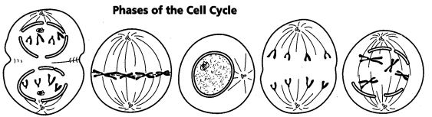
_____ _____ _____ _____ _____

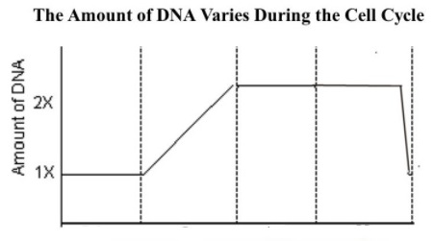
- When looking at the graph below which section of the graph represents the S phase of interphase? (highlight this portion of the line graph.

Explain why you picked that section.

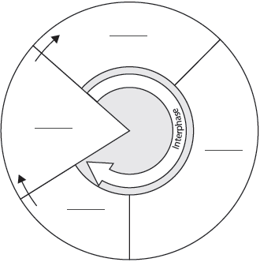
- Label the provided cell cycle diagram.

