**Biology Final Exam Review Fall 2017 Name: ___KEY_____________________**

**Scientific Method**

1. Match the following terms with the correct definition.

__B__ 1. Independent variable a. Data that is numerical.

__G__ 2. Dependent variable b. Variable that is manipulated and is given to the experimental group(s).

__F__ 3. Experimental group c. Information collected during an experiment.

__E__ 4. Control group d. Data that is in the form of word descriptions.

__H__ 5. Constants e. The group that gets the standard or normal conditions.

__C__ 6. Data f. The group that gets the independent variable.

__D__ 7. Qualitative Data g. Variable that is measured and responds to the testing.

__A__ 8. Quantitative Data h. Factors in an experiment that must remain the same in all groups.

__I__ 9. Hypothesis i. An if/then statement that predicts the outcome of an experiment.

2. A student studied the effects of increases in temperature on the respiration rate of yeast cells. He varied the temperature from 10 degrees Celsius to 40 degrees Celsius, and counted the number of carbon dioxide bubbles given off at the different temperatures. He kept one yeast culture at room temperature during the entire experiment. Results are given in the table below.

Temperature (degrees Celsius) Number of Carbon Dioxide Bubbles

10 3

1. 11
2. 18
3. 30
4. What is the question the scientist is trying to answer?

*GRAPH IT!!*

How does temperature affect yeast respiration?

1. What is the independent variable?

temperature

1. What is the dependent variable?

carbon dioxide bubbles

Number of CO2 bubbles

1. What is the control in this experiment?

Yeast culture group kept at room temperature

1. Write one sentence explaining the results of the

Temperature

experiment.

As the temperature increases, the yeast respiration

increases as shown by increasing CO2 bubbles.

f. How do you know which axis to graph the variables on?

(How can DRY MIX help you?) Label the graph with the correct variables on the correct axes.

DRY MIX = Dependent variable is graphed on the y-axis and the independent variable is graphed

on the x-axis.

**Biochemistry**

1. Explain the difference between a monomer and a polymer:

_A polymer is a large molecule (macromolecule) made of many smaller units called monomers.______

2. What element do all organic compounds contain? carbon_______________

3. Key characteristics of carbohydrates

1. What is the function of carbohydrates in the body? Quick source of energy
2. What are some examples of carbohydrates?_sugars, bread, pasta, cake, candy, glucose, lactose, etc.
3. What is the monomer? _monosaccharide_______________________
4. What elements are found in carbohydrates? _C, H, O in 1:2:1 ratio___________________
5. What letters do many carbohydrates end in? _-ose_____________________________

4. Key characteristics of lipids

* 1. What is the function of lipids in the body?__Long term energy storage
  2. What are some examples of lipids? _fats, oils, butter, waxes, steroids_________
  3. What is the monomer? _triglyceride (one molecule of glycerol+ 3 fatty acids)_____________

d. What elements are found in lipids? _C, H, O in no particular ratio__________

5. Key characteristics of proteins

* 1. What are the main functions of proteins in the body? Structural components that make up skin, hair, nails, muscle, bone; plays a role in our immune system; enzymes regulate cell reactions.
  2. What are some examples of proteins? _meats, beans, eggs, enzymes_
  3. What is the monomer? __amino acids__

d. What elements are found in protein? C, H, O, N, S___

6 Key characteristics of nucleic acids

1. What is the function of nucleic acids? _stores and transmits genetic information_
2. What are examples of nucleic acids? _DNA and RNA_________________________
3. What is the monomer? _nucleotide________________________________________
4. What elements are found in nucleic acid? _C, H, O, N, P__________________________

7. What macromolecule is an enzyme? __protein__________________________

a. What is the function of enzymes in the body? _They speed up chemical reactions.

b. How do enzymes affect activation energy? They lower the activation energy.

8. Label the following letters below. 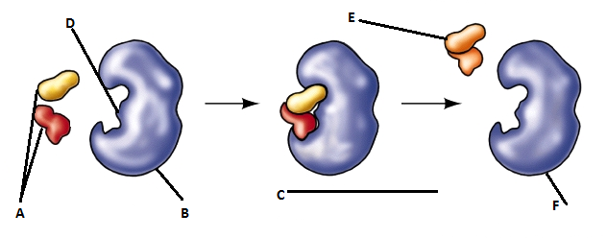

a. substrates___ d. _active site____

b. enzyme_________ e. _products_________

c. enzyme-substrate complex f. _enzyme______

9. Use the graph below to answer the questions on the right.

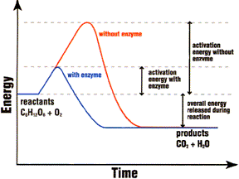

a. Which line to the left (A or B) represents the use of an enzyme in the chemical reaction? _B__________

b. Which line to the left (A or B) represents the chemical reaction without an enzyme? __A___________

c. Which letter represents the reactants? __ __C_______

d. Which letter represents the products? __D___________

e. Does this graph represent an endergonic reaction or an exergonic reaction? _EXERGONIC____

**A**

**B**

**C**

**D**

**The Cell Structure & Function**

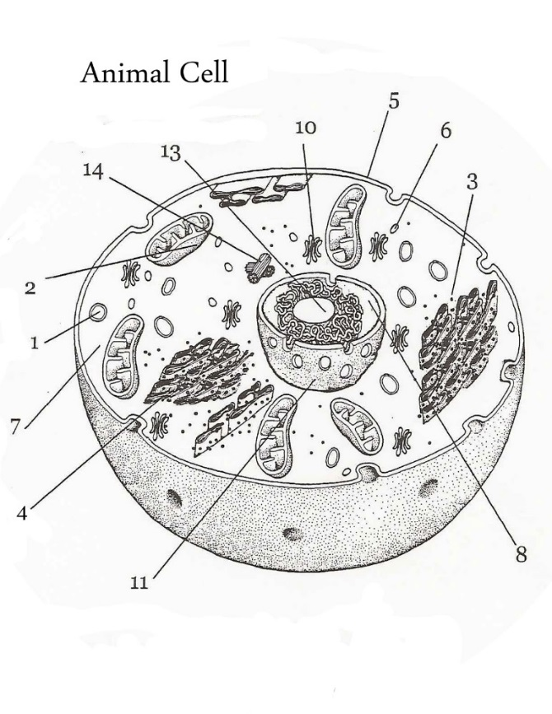

1. Label the cell to the right.

Cell membrane

2. Is this an animal cell or a plant cell? (Circle)

nucleolus

microtubules

lysosome

3. How do you know? It does not have a cell wall,

centrioles

ribosome

It has centrioles and lysosomes.

4. List three differences between an animal cell

mitochondria

and a plant cell. _Plant cells have chloroplasts,

vacuole

_cell walls, and large central_

cytoplasm

_vacuole and animal cells do not.

5. Is this cell a prokaryote or a eukaryote? (Circle)

ER

6. How do you know? It has a nucleus.

Nuclear membrane

nucleus

7. State the three parts of the cell theory

a. All organisms are made up of cells.

b. Cells are the basic unit of structure and function.

c. All cells come from pre-existing cells.

8. Fill out the chart by writing only one or two words to describe the function of the organelle.

|  |  |
| --- | --- |
| **Major Organelle** | **Function** |
| a. Mitochondria | Site of cellular respiration; provides energy |
| b. Nucleus | Control center; houses DNA |
| c. Cell Wall | Outer boundary providing structure and support |
| d. Ribosome | Site of protein synthesis; makes proteins |
| e. Endoplasmic Reticulum | Transportation system; can be rough or smooth |
| f. Golgi apparatus | Folds and packages proteins for export |
| g. Cell membrane | Regulates what goes into and out of cell |
| h. Vacuole | Storage of food, water, wastes |
| i. Lysosome | Digests wastes and old cell parts |
| j. Centriole | Produces spindle for cell division |
| k. Chloroplast | Site of photosynthesis; makes food (glucose); contains chlorophyll |

**Cell Transport**

1. Match the following terms.

_B___ 1. Passive Transport a. Form of active transport that involves the cell membrane engulfing particles

(this includes phagocytosis and pinocytosis).

_E___ 2. Active Transport b. Type of transport that does not involve energy; [high] to [low].

_G___ 3. Diffusion c. Form of passive transport that involves diffusion of water across membrane.

_C___ 4. Osmosis d. Form of passive transport that involves use of transport proteins.

_D___ 5. Facilitated Diffusion e. Type of transport that does require energy; [low] to [high].

_A___ 6. Endocytosis f. Form of active transport that involves the cell membrane pushing out particles.

_F___ 7. Exocytosis g. Form of PASSIVE transport that involves movement of small particles.

2. What is the phospholipid bilayer? Another name for cell membrane because it is composed of two layers of

phospholipids.

3. The cell membrane is described as selectively permeable or semi-permeable. What does this mean? It is picky about what goes into and out of the cell.

4. Draw what the cell to the right would look like if placed in the following solutions. Show the direction of water flow with arrows.

Isotonic Hypertonic Hypotonic

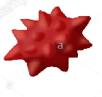



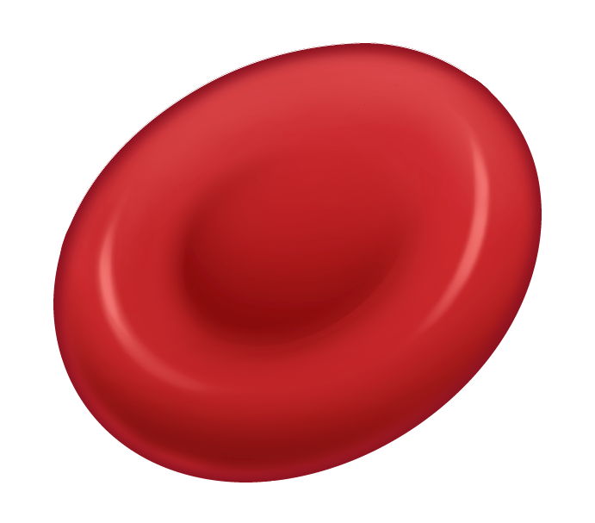

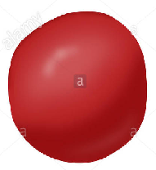

**Cell Energy**

1. What is ATP and what is its function? Adenosine Triphosphate; provides energy to the cell.
2. How does ATP provide energy to the cell (what happens)? By breaking off the third phosphate group.

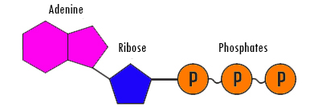

1. 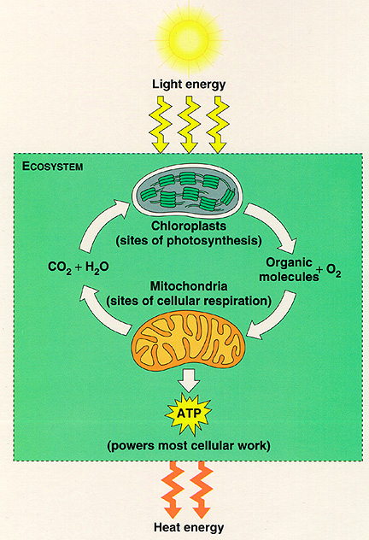Make a rough sketch of ATP to the right and include each of the parts.

4. Fill in the missing pieces of the picture:

A. *What are the reactants of photosynthesis and the products of cellular respiration?*

Carbon dioxide, water, energy

B. *What are the products of photosynthesis and the reactants of cellular respiration?*

Glucose, oxygen

C. *In what organelle does photosynthesis occur?* chloroplast

D. *In what organelle does cellular respiration occur?* mitochondria

**C**

**B**

**A**

**D**

5. What is the relationship between photosynthesis and cellular respiration?

The reactants of one are the products of the other; they are opposite processes.

6. Fill out the chart on the two types of respiration:

|  |  |  |
| --- | --- | --- |
|  | **Aerobic** | **Anaerobic** |
| **Oxygen required?** | **Yes** | **No** |
| **Steps?** | **1. Glycolysis**  **2. Krebs Cycle**  **3. Electron Transport Chain** | **1. Glycolysis** |
| **Net ATP/ Products?** | **36 ATP** | **2 ATP** |

7. Complete the following table.

|  |  |  |
| --- | --- | --- |
|  | **Photosynthesis** | **Cellular Respiration** |
| **What type of organisms do this?** | Plants and plant-like organisms | All eukaryotes do aerobic |
| **Cell organelle process occurs in** | Chloroplast | Mitochondria |
| **Overall Equation** | 6CO2 + 6H2O + sunlight 🡪 C6H12O6 + 6O2 | C6H12O6 + 6O2 🡪 6CO2 + 6H2O + 36 ATP |

**Cell Reproduction**

1. Use the following chart to check which statement applies to mitosis, meiosis or both.

|  |  |  |
| --- | --- | --- |
| **Statement** | **Mitosis** | **Meiosis** |
| Nucleus and nuclear membrane break down | X | X |
| Sister chromatids move to opposite ends of the cell | X | X |
| Centrioles form spindle fibers | X | X |
| Homologous chromosomes pair to form tetrads |  | X |
| Crossing over occurs |  | X |
| Makes somatic cells, such as lung cells | X |  |
| Makes gametes, such as egg and sperm |  | X |
| Makes daughter cells | X | X |
| Associated with asexual reproduction | X |  |
| Associated with sexual reproduction |  | X |
| Daughter cells are genetically identical | X |  |
| Daughter cells are genetically different |  | X |
| Begins with the diploid number of chromosomes | X | X |
| Ends with the diploid number of chromosomes | X |  |
| Ends with the haploid number of chromosomes |  | X |
| Creates 2 daughter cells | X |  |
| Creates 4 daughter cells |  | X |
| Chromosomes move to the equator of the cell | X | X |
| Has one division cycle | X |  |
| Has two division cycles |  | X |

2. Use the following picture to answer the questions that follow.

a. Which diagram represents mitosis? ___A___

b. Which diagram represents meiosis? ___B___

c. What is the diploid number of both diagrams? __4____

d. What is the haploid number? __2___

e. Which diagram ends with the diploid number of chromosomes? __A____

f. Which diagram ends with the haploid number of chromosomes? __B____

e. What type of daughter cells will form from the division process in A? somatic cells

f. What type of daughter cells will form from the division process in B? sperm or egg (gametes)

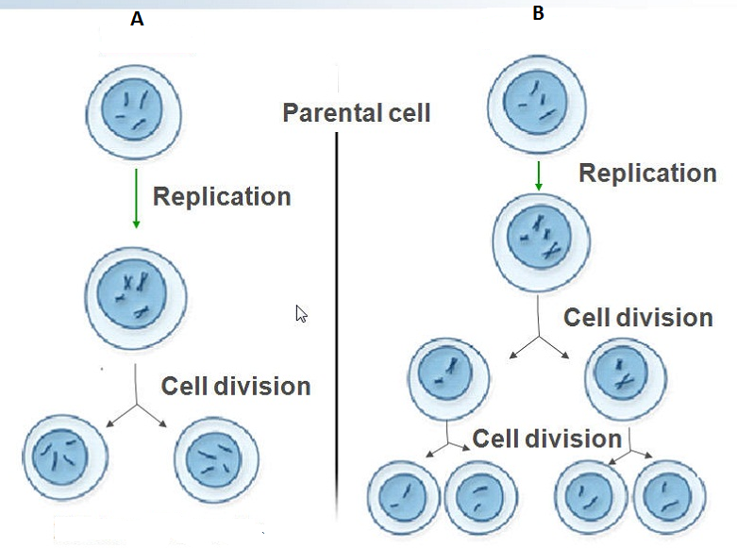

3. Label the parts of the cell cycle below.

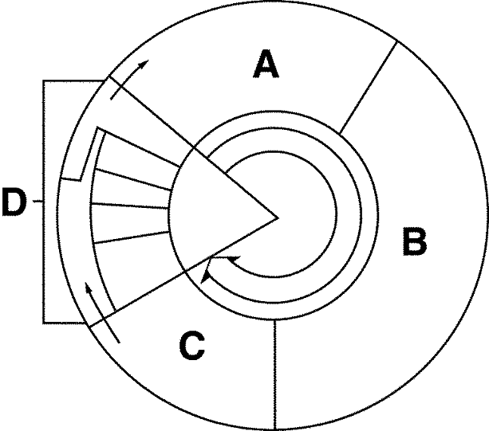

A. G1

B. S

C. G2

A, B, and C make up: interphase

D. M Phase (cell division)

Parts of D: prophase, metaphase, anaphase, telophase, cytokinesis

4. Label the different types of DNA as they exist in interphase and mitosis and meiosis as well as their parts: chromatin, doubled chromosome, centromere, sister chromatids, single chromosome, tetrad/homologous chromosomes.

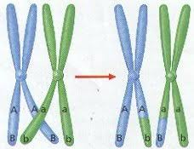



centromere

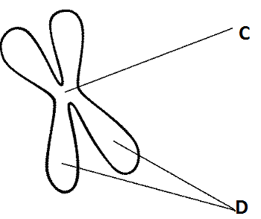

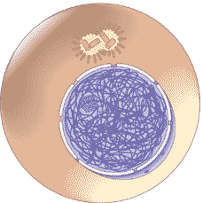

Sister chromatids

A chromatin B doubled chromosome E single chromosome F tetrad composed of two

homologous chromosomes

5. What is crossing over? Exchange of genetic information between homologous chromosomes in the tetrad

6. Does it occur during mitosis or meiosis? Meiosis only

7. During what phase does it occur? Prophase I

**Genetics**

1. Match the following terms with the correct definition.

__B__ 1. Gene a. A trait that is hidden or masked by a more powerful trait.

__D__ 2. Genotype b. A segment of DNA that codes for a specific trait.

__F__ 3. Phenotype c. Principle stating that some traits overpower other traits.

__H__ 4. Allele d. Two letter combination of alleles for a given trait. Ex: Bb

__K__ 5. Homozygous e. Principle stating that when alleles separate they do it independently.

__M__ 6. Heterozygous f. Physical appearance of a trait as determined by the genotype. Ex: Green

__N__ 7. Genetics g. Principle stating that alleles separate during gamete formation.

__I__ 8. Punnett Square h. An alternate form of a gene represented by a single letter.

__L__ 9. Dominant i. A tool used to predict the probability of the offspring’s traits.

__O__ 10. Incomplete Dominance j. The offspring express both traits of the parents equally.

__J__ 11. Codominance k. Describes a genotype where both of the alleles are the same.

__G__ 12. Law of Segregation l. A trait that overpowers or masks another trait.

__E__ 13. Law of Independent Assortment m. Describes a genotype where one allele is dominant and one is recessive.

__C__ 14. Law of Dominance n. The study of heredity.

__A__ 15. Recessive o. The offspring express the traits of both parents as a blend or mixture.

2. Complete Dominance Problem

In humans, having dimples is dominant over not having dimples.

Cross a man who is heterozygous for the dimples trait with a

D d

Woman who does not have dimples. Use the letter D.

d

d

dd

Dd

Parents: _Dd____ x ___dd________

Genotypic ratio: _0 DD: 2 Dd: 2 dd__

dd

Dd

Phenotypic ratio: _2 Dimples: 2 no Dimples_

3. Incomplete Dominance Problem

In rabbits, a brown fur coat is the result of a blend between

red fur and white fur. Assign genotypes to the following

phenotypes. Then cross two brown fur rabbits. Use the letter R.

R r

Red fur genotype: __RR____

Rr

RR

R

r



Brown fur genotype: _Rr_____

White fur genotype: __rr____

rr

Rr

Parents: __Rr________ x __Rr_________

Genotypic ratio: _1 RR: 2 Rr: 1 rr__

Phenotypic ratio: _1 red: 2 brown: 1 white_

4. Codominance Problem

In chickens, a checkered feather pattern (BW) is a combination of both

black (BB) and white feathers (WW). Both black feathers and white

feathers are dominant and equally expressed in the offspring. Cross two

checkered chickens.

B W

B

W

Parents: __BW________ x __BW_________

BW

BB



Genotypic ratio: _1 BB: 2 BW: 1 WW___

WW

BW

Phenotypic ratio: _1 black: 2 checkered: 1 white__

**Classification**

1. List the taxa in order from broadest to most specific starting with the category of domain.

Domain, Kingdom, Phylum, Class, Order, Family, Genus, Species

2. Which two levels are used in binomial nomenclature, the naming of organisms?

__Genus_____ and __Species_____

3. Write the scientific name of a human (HOMO SAPIENS) correctly.

*Homo sapiens*

4. Which two organisms in the table below are most closely related? _Humpback whale and spider monkey

|  |  |  |  |  |
| --- | --- | --- | --- | --- |
| **Classification of Four Organisms** | | | | |
|  | **Corn** | **Whale**  **Shark** | **Humpback Whale** | **Spider Monkey** |
| **Kingdom** | Plantae | Animalia | Animalia | Animalia |
| **Phylum** | Anthophyta | Chordata | Chordata | Chordata |
| **Class** | Monocotyledones | Chondrichthyes | Mammalia | Mammalia |
| **Order** | Commelinales | Squaliformes | Cetacea | Primates |
| **Family** | Poaceae | Rhincodontidae | Balaenopteridae | Atelidae |
| **Genus** | Zea | Rhincodon | Megaptera | Ateles |
| **Species** | *Zea mays* | *Rhinacodon typus,* | *Megaptera novaeangilae* | *Ateles paniscus* |

**Viruses**

1. Viruses (are/are not) considered living because they do not have all 8 characteristics of living things.

2. Viruses are specific to their host cells. A virus that infects a bacterium is called a bacteriophage.

3. Label the structure of the typical bacteriophage below:

4. What are all 8 characteristics of living things? List them below.

Composed of cells, reproduce, obtain materials for energy, have DNA, RNA and macromolecules, grow and develop, change over time, respond to stimuli, homeostasis.

5. Highlight the ones that do not apply to viruses.

A. capsid composed of protein

B. DNA or RNA but not both

C. Body sheath

D. Tail fibers

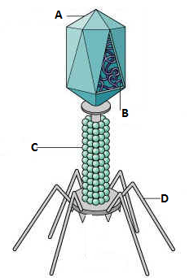

6. Which virus replication cycle results in immediate death of the host cell? Lytic cycle

7. Which virus replication cycle results in a host cell that has the virus integrated into its own DNA and doesn’t destroy the host cell until after it has undergone cell division? Lysogenic cycle

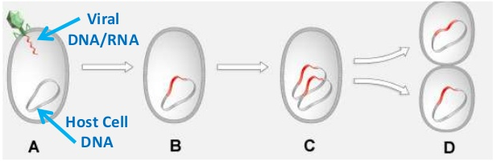

8. Draw a prophage being integrated into the host DNA and label in the space below.

**Kingdoms**

1. What are the two Kingdoms of Bacteria? Eubacteria and Archaebacteria

2. What is the main difference between these two kingdoms? Archaebacteria does not have peptidoglycan in their cell walls and Eubacteria does have peptidoglycan in its cell wall.

**For the following kingdom characteristics, circle the correct answer within the parentheses.

3. Bacteria are (prokaryotes/eukaryotes) and are (unicellular/multicellular/both). What does their genetic information look like in their cells? A single circular chromosome

4. Kingdom Protista is composed of organisms that are (prokaryotes/eukaryotes), (unicellular/multicellular/both) and may be animal-like, plant-like or fungus-like.

5. Kingdom Fungi is composed of organisms that are (prokaryotes/eukaryotes), (unicellular/multicellular/both) and are (autotrophic/heterotrophic/heterotrophic decomposers). How do fungi reproduce? spores

6. Kingdom Plantae is composed of organisms that are (prokaryotes/eukaryotes), (unicellular/multicellular/both) and are (autotrophic/heterotrophic/heterotrophic decomposers).

7. Label the diagram of the flower below and write the function of each of the parts.

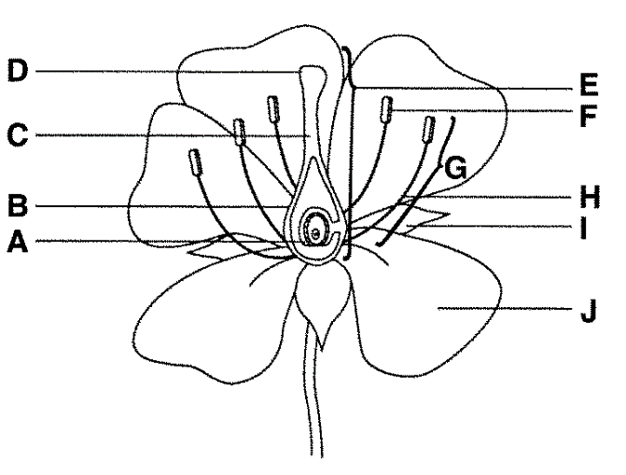

Flower Part Function

A. Ovule haploid gamete (egg)

B. Ovary houses the ovule

C. Style tube which the pollen falls

D. Stigma sticky; attracts pollen (sperm)

E. Carpel/Pistil entire female reproductive organ

F. Anther produces pollen (sperm)

G. Stamen entire male reproductive organ

H. Filament stem that raises the anther high

I. Sepal protects the flower before it buds

J. Petal colorful to attract pollinators

8. What is the difference between the three plant tropisms below?

a. Phototropism- plants grow toward/bend toward light source

b. Thigmotropism- plants grow in response to touch.

c. Gravitropism- plant roots grow in direction of gravity; plant stems grow away from direction of gravity. Roots are positively gravitropic and stems are negatively gravitropic.

9. Kingdom Animalia is composed of (prokaryotes/eukaryotes), (unicellular/multicellular/both) and are (autotrophic/heterotrophic/heterotrophic decomposers). Animals are broadly divided into two groups: vertebrates and invertebrates.

10. Invertebrate Characteristics: write what types of organisms are in these groups and a major characteristic.

a. Phylum Porifera- sponges; sessile, full of pores, filter feeders

b. Phylum Cnidaria- jellyfish, sea anemonae; stinging cells

c. Phylum Platyhelminthes- flatworms such as tapeworm; one body opening

d. Phylum Nematoda- roundworms such as Ascaris; most are parasitic, two body openings

e. Phylum Annelida- segmented worms such as earthworms

f. Phylum Mollusca- clams, octopus, snails; muscular foot

g. Phylum Arthropoda- insects, spiders; jointed appendages, exoskeleton

h. Phylum Echinodermata- starfish, sand dollars, sea urchins; spiny skin

11. Vertebrate Characteristics from Phylum Chordata: write what types of organisms are in these groups and a major characteristic.

a. Class Agnatha- jawless fish; no hinged jaws

b. Class Chondrichthyes- cartilaginous fish such as sharks; cartilage skeleton

c. Class Osteichthyes- bony fish such as salmon, perch; bony skeleton

d. Class Amphibia- amphibians such as frogs, toads, salamanders; dual life on land and in water

e. Class Reptilia- reptiles such as snakes, lizards, turtles; dry, scaly skin, amniotic egg, claws on toes

f. Class Aves- birds; feathers, hollow bones

g. Class Mammalia- mammals; give milk to young